**December 2024**

ST. PAUL'S LUTHERAN CHURCH

3487 NORTH BOSTON ROAD

EDEN, NY 14057

716.992.9112

stpaulseden.com



**Pastor: Rev. Thomas Lutz**

**Director of Ministries: Tina Rigley**

**Associate Director of Ministries: Lisa Hoover-Beller**

**Family/Youth Ministry Coordinator: Morgan Parnitzke**

**Organist: Jacob DeGarie**

**Caretakers: Kassidy Beller and Asher Parnitzke**

***LINKS to recordings of***

***our Worship Services***

***and all updates can be found on***

***our website: stpaulseden.com***

***Please call Pastor Lutz   
(716.818.9860)   
for any emergencies.***



**Join us on Facebook:**

**St. Paul’s Eden Worship (public group)**

**St. Paul’s Lutheran Friends (private group)**

**St. Paul’s Lutheran Church**

**Our Website**

**Don’t forget to check out our**

**amazing website! Information about services, events, programs and schedules can be**

**found there!**

**Go to:**

**stpaulseden.com**

**WHAT ARE WE CELEBRATING?**

**By Pastor Lutz**

Once again we begin to prepare to celebrate Christmas. But what are we celebrating? I am not asking with what we are celebrating, but what exactly are we celebrating? I am also not asking this question on a global scale because that is also a very different thing than WE are celebrating.

Are we celebrating a babe wrapped in swaddling clothes? Yes, we are but it is an image that many of us do not take the time to really understand. Even when we make the statement that this babe is born to die, there is more to it. You many wonder what I mean by this. Why did the Word of God come as a baby? The Word is the sacrifice for our sins, but couldn’t He have just come to us as an adult who was a fully formed human being? Couldn’t He have done His three years of ministry and died and rose for us? Apparently not or this would have been the case when Christ came to us.

God does not send His Son into the world as a baby for no reason. The man who died for us needed to be one of us, experience what it means to be born and live a life in this fallen and broken world. Part of the sacrifice on Good Friday is wrapped up in the Word by whom everything was created becoming one of His creations.

When we think about what we are celebrating this holiday season, we must remember that we are rejoicing and worshiping a God who has done everything to be one of us. That includes humbling Himself. We are celebrating a love that is too deep for us to really truly understand.

**ADULT BIBLE STUDY**

Join Pastor on Sunday mornings at 9:30 for a Bible Study on the book of Romans.

**DEVOTIONS AT FOUR CORNERS**

Join Pastor at the Four Corners Café for a Devotion/Bible Study! The group will meet on Thursday, December 5 & 19 at 8:30 am.

**EDEN HEIGHTS BIBLE STUDY**

Bible Study with Pastor Lutz and Pastor Kate (Eden United Methodist Church) will meet at 1:30 pm at Eden Heights. They will gather on Thursday, December 12.

**CATECHISM BIBLE STUDY**

We will continue to study the catechism on the 2nd & 4th Wednesday of the month from 9:30 am-11 am. Come and explore the catechism which contains the basic teaching of the Lutheran Church. You did this when you were young but there is still so much to learn! Bonus- this time there is no required memory work! We will meet on Wednesday, December 11.

**BOOK CLUB**

Look for information about the next book club in the weekly church bulletin. Call Cheryl Colvin at 716.992.4032 if you are interested in joining or have any questions. New members are always welcome.

**D&D MEETING**

The next D&D meeting will be on Sunday, December 1 at 1 pm. Meet at Genesis Gaming and Hobby in Eden. Please contact Pastor at 716.818.9860 for info.

**IN-HOUSE WORSHIP SERVICES:**

**REGULAR SERVICES**

**Traditional Service**

**8:30 am (every week)**

**10:45 am (2nd & 4th Sundays)**

**Contemporary Service**

**10:45 am (1st, 3rd & 5th Sundays)**

**Wednesday Contemporary Service with Communion (Chapel)**

**11:15 am (2nd & 4th Wednesdays)**

**In addition to our in-house worship services, our live-stream worship services are on Facebook. Go to St. Paul’s Worship Group. Or go to our website: stpaulseden.com for a link.**

**OPTIONS FOR SEATING**

There is a pew located towards the back of church to assist those with limited mobility. This includes people who utilize wheelchairs, walkers, canes or crutches due to physical challenges, recent surgeries or injuries. We hope this is a welcome addition for anyone who may need accommodations!

**YOUTH CHRISTMAS SERVICE**

On Sunday, December 22 at the 10:45 am service our Sunday School youth will host our service. Each class will participate in the service to make it a very special time of worship. Please join us and support our youth, while celebrating the miracle of the season.



**Are you going**

**into the hospital for**

**any type of surgery?**

**Pastor Lutz**

**would like to “visit”**

**with you before your**

**surgery to pray**

**with you.**

**Please call the church**

**office (716.992.9112) or**

**Pastor’s cell**

**716.818.9860**

**to let him know**

**of your surgery.**

**ALZHEIMER’S**

**ASSOCIATION**

Website: alz.org/wny

24/7 Helpline

1.800.272.3900



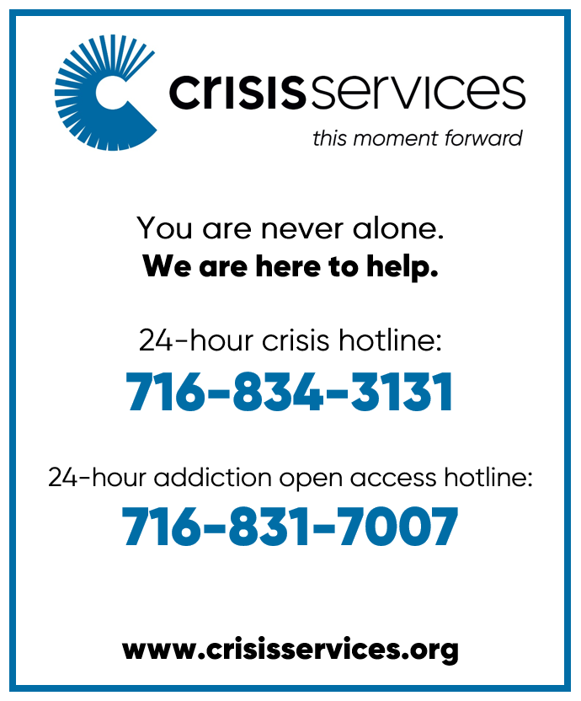

**THE L.E.G.O.S.**

**House**

**A Community Spiritual**

**Support Center**

***For further information on***

***our support groups or to inquire about individualized Christian Care by a trained***

***Stephen Minister or staff***

***member, please call***

***716.992.9112.***

**Need a ride?**

If you are in need of a ride there

are resources available:

* Rural Transit Service-call 716.662.8378 for information
* Eden town car- call Eden Service Line at 716.992.3067
* Hamburg Van Service- call 716.646.0665

We can help YOU with your prayers. God is waiting for

your requests. Call us with any you might have. Please

make your special prayer

requests by calling our

Prayer Chain Coordinator,

Morgan Parnitzke at

716.992.9112.



Please make your special prayer requests by calling

our Prayer Chain

Coordinator,

Tina Rigley

at 992.9112 or

texting 998.8726.

**PRAYERS**

**WE ARE HAPPY** to honor requests for prayersfor the sick especially when they are in the hospital, in rehab, in hospice or in a post op recovery. When your loved one has improved, please be sure to call Lisa Beller at 716.992.9112sowe can remove their names from the prayer list.

Periodically, the prayer committee will remove names from the prayer list. If you would like someone put back on, please contact Pastor Lutz or Lisa Beller at 716.992.9112.



**IN OUR PRAYERS** for the Lord's healing power we include the following members:

* **Rose Hofner**
* **Harvey Quigel**
* **Laura Feasley**
* **Maryetta Lootens**
* **Mark Gabel**

**PRAYER LIST**

Please contact the church office at 716.992.9112 to have a loved one placed on the Prayer List.

**IN OUR PRAYERS** for the Lord's healing power we include the following family and friends of our church members:

* **Sue Kester** (Lynn Gerber’s friend)
* **Daniel Snyder & Holly Uebhuler** (Jeff Snyder’s father & sister)
* **Julie Buzzard** (Kirsten Henderson’s friend)
* **Bill Robison III**
* **Cheryl Bristol, Annette Bove & Jennifer Brooks** (Amy Smith’s friends)
* **Stefanie Wutz** (Laurie Agle’s daughter-in-law)
* **Joanne Pepper** (Patty Smoot’s friend)
* **Janice McKay** (Eileen Seltzer’s mother)
* **Ken Roberts** (Charmayne Zieziula’s family)
* **Albert Burkhart** (Cally Burkhart’s father)
* **Matt** (Robin Palumbo’s nephew)
* **Renee** (Pastor’s niece)
* **Laurie** (Gary Holscher’s friend)
* **Mary Hewson** (Nancy Theriault’s friend)

 **ALTAR FLOWERS**

If there is a special date or a person you would like to honor, please consider placing flowers on the Altar. Please call Lisa Beller at 716.992.9112.

**DECEMBER 1- In loving memory of Cheryl Agle,** from her Family

**DECEMBER 8- In remembrance of her love of the season.** The Family of Marion Klein

**DECEMBER 15-** **In loving memory of Mr. & Mrs. Arthur Bauer and** **Mr. & Mrs. Marcus Enser** by Mr. & Mrs. John Bauer & Family

**DECEMBER 22-In memory of our loved ones** by Keith, Laura & Alice Feasley

**DECEMBER 29- To the Glory of God** by Joe & Kristen Winiecki

**JANUARY 5, 2025- In loving memory of Henry & Ruth Agle** by the Family

**Christ the Savior is born!**

**AVERAGE WEEKLY**

**SUNDAY SCHOOL**

**ATTENDANCE**

**This includes youth and adult classes**

October 13- 48

October 20- 46

October 27- 52

November 3- 54

November 10- 55

**FINANCIAL**

**BAROMETER 2024**

Thru November 10, 2024

Budgeted to date $227,576

Given to date $213,806

**THANK YOU**

for your generous giving!!

All of our bills are

up to date!

**

***MANY THANKS FOR***

***CONTINUED SUPPORT***

***AND GENEROSITY!***

**AVERAGE WEEKLY**

**“IN-HOUSE” WORSHIP**

**ATTENDANCE:**

October 13- 125

October 20- 96

October 27- 98

November 3- 126

November 10- 127

**L.E.G.O.S. HOUSE**

The L.E.G.O.S. House is used for support groups, supervisions and continuing education for Stephen Ministers, as well as contracted counseling and Outreach/ Workshops. From January 1, 2024- October 31, 2024 total usage was: 372 times

**Information Update:**

Please contact Lisa Beller at

716.992.9112 if any of your

personal information has

changed. Remember to contact

us with your new address if you

are moving. Thank you!

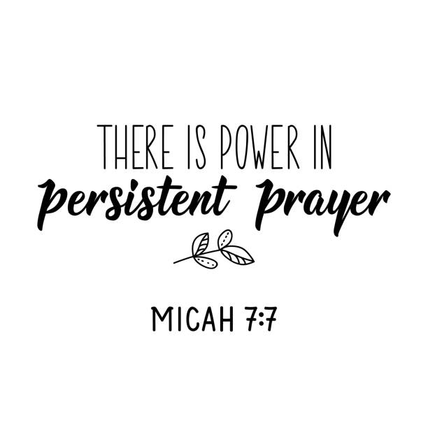

2025

Offering envelopes will be

available December 8th.

**Youth News**

**Creation Kids (ages 2-5; PreK)**

**Wonder Kids (K-1st)**

**Discovery Kids (2nd-4th)**

**Confirmation Youth (5th-6th)**

**Inspire Youth Group (6th-12th)**

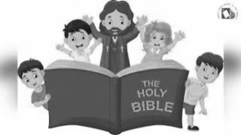

**CONFIRMATION CLASS**

THERE IS NO CONFIRMATION CLASS FOR FIRST YEAR STUDENTS ON TUESDAY, DECEMBER 10. ONLY 2ND YEAR SHOULD ATTEND. Also, there is no Confirmation class on Tuesday, December 24 & 31.

**WONDER KIDS/DISCOVERY KIDS**

**EDIBLE NATIVITY/CHRISTMAS EVENT**

Children in grades K-4th are invited to join us for a fun holiday event on Saturday, December 14 from 9am-11am. We will be creating the nativity scene with tasty materials you can take home to enjoy! Then we will be creating special Christmas gifts for your family and friends!

One of the best ways we can celebrate the birth of Jesus is by giving to others! We are asking all of the children who attend to bring a pair of new gloves, mittens, a hat or a scarf to donate.

You MUST PRE-REGISTER by December 8 to ensure we have enough supplies ready! This is a great time to finish that Christmas shopping parents! Call the church at 716.992.9112 or text Tina Rigley at 716.998.8726 or email tmrigley1012@yahoo.com.

**LEGOS HOUSE FUNDRAISER**

The Inspire Youth have created beautiful Christmas ornaments to be sold to support the LEGOS HOUSE. They will be selling the ornaments before and after services on December 17 and 22. Thank you in advance for your support!

**THE GIVING TREE**

We will be participating in the “Giving Trees of Love” for the Eden community again this year.

Please choose a tag and write your name on the corresponding number on the clip board that will be available at the table. Please take the tag, purchase the requested item, wrap the gift and attach the tag on the gift. **THE GIFT (WITH THE TAG) MUST BE RETURNED TO CHURCH BY SUNDAY, DECEMBER 8. ALL GIFTS CAN BE LEFT IN THE LIBRARY.**

Every tag is coded, so please only take a tag if you are able to donate a gift AND return it by December 8. Thank you in advance for your generosity to those in need this holiday season.

**CHRISTMAS CAROLING**

ALL AGES are invited to join us for Christmas Caroling on Sunday, December 8. Please meet at the church by 12:45 pm. We will be leaving to go to our first destination to sing at 1pm. Everyone will provide their own transportation (feel free to carpool) and we will return to the church after spreading Christmas love to enjoy hot chocolate and cookies! What a wonderful family event to spread cheer to others! Please sign up with Morgan Parnitzke at 716.992.9112

*Confirmation students will get a service hour (needed for Confirmation requirements) for this event.

**OPERATION CHRISTMAS CHILD**

Thank you to everyone who donated to this wonderful cause! Jan Henry and her amazing 5th graders put together 23 shoeboxes filled with little goodies and necessities to “demonstrate God’s love in a tangible way to children in need around the world” (Samaritan’s purse statement).

**CHRISTMAS TREE LIGHTING EVENT**

Mark your calendars for this special annual event. Please join us at the Eden Town Square on Saturday, December 7. The ceremony will take place at 7:30 pm and the lighting of the tree will be at 8 pm.

There will be festive, holiday music and hot chocolate and cookies will be served. Come and be part of this beautiful evening in the Eden community. Those attending are encouraged to bring an ornament to place on the tree.

This event is sponsored by St. Paul’s Lutheran Church and the Eden Chamber of Commerce.



**ASSEMBLE COOKIE PACKS**

Join us on Monday, December 9 from 6:30-7:30 pm to put together these festive cookie packs that will spread cheer to many this holiday season!

*Confirmation students will get a service hour (needed for Confirmation requirements) for this event.

**CHURCH REPAIR UPDATE**

We would like to share the status of the repair work on the church. As of November 18, the mitigation crew has completed their work. We are currently waiting for the insurance company to approve the estimate for the restoration company that will be taking over to complete the project. From the time they begin their work to their anticipated completed date it should be about 6-8 weeks.

The organ is a massive project and we have an excellent company tending to it. Heritage has been taking care of our organ for quite some time and their expertise, attention to detail and exquisite care to our precious organ has not wavered. However, we are not the only project they are working on and due to the extensive cleaning it remains unlikely we will have the organ for Advent or Christmas. We are thankful to have Jake, who is immensely talented, providing music on the piano for our services until we can enjoy our organ once again.

The Fellowship Hall, kitchen, balcony, and mens’ room remains closed. We will continue to keep you posted on the status of these areas of church. Due to the continued work being done there will be changes in some of the programming/events we have in December but our hope is that, if work begins soon, we will be able to function in a normal capacity at the start of 2025.

We would like to thank our church family for their continued patience and understanding as we persist down this road of repair and renovation. Please do not hesitate to come to any of the staff if you have any questions or concerns. We remain grateful for our blessings and look forward to a fresh start in 2025!

**YEAR OF PRAYER**

**JANUARY 2025**

*And now these three remain: faith, hope and love.*

*But the greatest of these is love.*

* Corinthians 13:13

*Our faith can move mountains.*

-Matthew 17:20

“*For I know the plans I have for you, “ declares the*

*Lord, “plans to prosper you and not to harm you, plans*

*to give you hope and a future.”*

-Jeremiah 29:11

*He comforts us in all our troubles so that we*

*can comfort others……*

-2 Corinthians 1:4

*Do not be anxious about anything, but in every situation, by*

*Prayer and petition, with thanksgiving, present your requests*

*to God.” -*Phillipians 4:6

*Be strong and courageous. Do not be afraid, do*

*not be discouraged, for the Lord your God will be*

*with you where you go.*

-Joshua 1:9