**january 2025**

ST. PAUL'S LUTHERAN CHURCH

3487 NORTH BOSTON ROAD

EDEN, NY 14057

716.992.9112

stpaulseden.com



**Pastor: Rev. Thomas Lutz**

**Director of Ministries: Tina Rigley**

**Associate Director of Ministries: Lisa Hoover-Beller**

**Family/Youth Ministry Coordinator: Morgan Parnitzke**

**Organist: Jacob DeGarie**

**Caretakers: Kassidy Beller and Asher Parnitzke**

***LINKS to recordings of***

***our Worship Services***

***and all updates can be found on***

***our website: stpaulseden.com***

***Please call Pastor Lutz   
(716.818.9860)   
for any emergencies.***



**Join us on Facebook:**

**St. Paul’s Eden Worship (public group)**

**St. Paul’s Lutheran Friends (private group)**

**St. Paul’s Lutheran Church**

**Our Website**

**Don’t forget to check out our**

**amazing website! Information about services, events, programs and schedules can be**

**found there!**

**Go to:**

**stpaulseden.com**

**ADJUSTING ON THE FLY**

**By Pastor Lutz**

One lesson we learned at St. Paul’s in 2024 was that we always need to be ready to adjust our plans at a moment’s notice. We, the staff, had spent time this summer planning for “A Year of Prayer” but then the fire happened in late August and we needed to change everything. After discussing possible options, we decided it would be best to shift our plans and begin in September of 2025.

I would prefer to think this kind of radical change is unique to the events of the second half of 2024. But in recent memory we have actually all lived through quite a few monumental moments that radically changed our lives. The events of 911 and getting through Covid are two of the biggest and most notable. Those events don’t even include the changes in our personal lives. I believe more than ever, we understand our world is apt to change radically without notice.

So as we look towards the year ahead, we can only be sure of one thing in 2025: God will be with us. He tells us He will be with us in every circumstance and His love for us is unchangeable.

*37No, in all these things we are more than conquerors through Him who loved us. 38For I am convinced that neither death nor life, neither angels nor demons, neither the present nor the futre, nor any powers, 39 neither height nor depth, nor anything else in all creation, will be able to separate us from the love of God that is in Christ Jesus our Lord. (Romans 8:37-39)*

So while the world around us may be in constant flux, we are grounded in the unchanging powerful love of God. So we go into this new year with the same love that got us through all of the other years- God’s.



**ADULT BIBLE STUDY**

Join Pastor on Sunday mornings at 9:30 for a Bible Study.

**THE MEDIATION ROOM**

This month we will be introducing the Mediation Room. It is a hour long nontraditional bible study. It will be a music-based approach to studying lessons from scripture. The music will not be traditional hymns but, instead, be modern based music ranging from the heavy rock and roll of Skillet to the melodic inspirational lyrics of Casting Crowns. The music will not be exclusive to Christian bands but will also include some secular music that has Christian overtones such as “My Own Prison” by Creed. This song, in fact, will be the song that will be used the first week of this bible study.

The structure of the bible study will consist of Pastor choosing a few songs to listen to. Requests will also be taken and one song at a time will be heard by the group. The group will listen to the song, focusing on the lyrics and meditate on the meaning. Lyrics of the songs will be provided, along with a couple of appropriate bible verses. Following the mediation time, we will discuss what we get from the music. In some cases we may listen to a song more than once before moving on to the next one. Please join us to meditate on God’s word while enjoying music that inspires the soul.

**DEVOTIONS AT FOUR CORNERS**

Join Pastor at the Four Corners Café for a Devotion/Bible Study! The group will meet on Thursdays, January 2,16 & 30 at 8:30 am.

**EDEN HEIGHTS BIBLE STUDY**

Bible Study with Pastor Lutz and Pastor Kate (Eden United Methodist Church) will meet at 1:30 pm at Eden Heights. They will gather on Thursdays, January 9 & 23.

**CATECHISM BIBLE STUDY**

We will continue to study the catechism on the 2nd & 4th Wednesday of the month from 9:30 am-11 am. Come and explore the catechism which contains the basic teaching of the Lutheran Church. We will meet on Wednesdays, January 8 & 22.

**IN-HOUSE WORSHIP SERVICES:**

**REGULAR SERVICES**

**Traditional Service**

**8:30 am (every week)**

**10:45 am (2nd & 4th Sundays)**

**Contemporary Service**

**10:45 am (1st, 3rd & 5th Sundays)**

**Wednesday Contemporary Service with Communion (Chapel)**

**11:15 am (2nd & 4th Wednesdays)**

**In addition to our in-house worship services, our live-stream worship services are on Facebook. Go to St. Paul’s Worship Group. Or go to our website: stpaulseden.com for a link.**

**OPTIONS FOR SEATING**

There is a pew located towards the back of church to assist those with limited mobility. This includes people who utilize wheelchairs, walkers, canes or crutches due to physical challenges, recent surgeries or injuries. We hope this is a welcome addition for anyone who may need accommodation

**GIVING ENVELOPES**

Over the past few years the usage of giving envelopes for support of St. Paul’s has dropped dramatically. We recognize that for many this is simply not the convenient or the desired way to give. **This is not an issue** **at all and we want to stress that you do NOT need your envelopes to receive credit for your giving to the church**. As long as your name OR assigned number is with your giving, you will get credit. EVERYONE is given a number, if they use their envelopes or not. By using your name or number we can still record any giving and you will receive a statement for your giving. For those who do wish to continue to use their envelopes, they can be found in the coatroom off of the Narthex.

We have also noticed a significant decline in pledges. If you wish to continue to pledge you may fill out a pledge sheet and return it in the offering plate or to Carolyn Liljequist or Tina Rigley. Pledge forms can be found in the back of church.

**CHURCH REPAIR UPDATE**

The staff would like to thank our church family for their continued support with the changes and adjustments that have had to be made during this transitional time. We continue to make progress to get to 100% utilization of the church building.

The repair crew was able to start in December. The work that still needs to be done is quite extensive and, therefore, the completion timeline is approximate. We are hopeful it will be done by the beginning of February. As soon as it is safe we will get the elevator accessible. In addition, there have been quite a few inquiries regarding the Jesus painting. Once all of the painting of the walls are completed, the painting will return to its place on the sanctuary wall.

Despite it being their busiest time of the year, Heritage Organs has been able to get most of the organ’s pipes cleaned and repaired at their workshop. The blower and the reservoir portion of the organ still needs to be cleaned properly when they are able to have access into the Fellowship Hall. Additionally, tuning is required and then the pipes will be returned and installed. Jake continues to provide us beautiful music each week on the piano.

Besides the emotional support and positive attitudes so warmly provided by our members, we continue to be overwhelmed by our church family’s generosity. We thank you endlessly for your continued giving to St. Paul’s and the ministries provided here. Each contribution makes a difference maintaining this church and our amazing ministries.

Although we are not yet functioning as we would like, we are blessed in so many ways. That will continue to be our focus and soon we will be returning to many of the activities and programs we have missed. Until then- let us remain thankful!

We wish you peace, joy and good health in 2025! L.E.G.O.S.!!

**ALZHEIMER’S**

**ASSOCIATION**

Website: alz.org/wny

24/7 Helpline

1.800.272.3900

**Are you going**

**into the hospital for**

**any type of surgery?**

**Pastor Lutz**

**would like to “visit”**

**with you before your**

**surgery to pray**

**with you.**

**Please call the church**

**office (716.992.9112) or**

**Pastor’s cell**

**716.818.9860**

**to let him know**

**of your surgery.**



**THE L.E.G.O.S.**

**House**

**A Community Spiritual**

**Support Center**

***For further information on***

***our support groups or to inquire about individualized Christian Care by a trained***

***Stephen Minister or staff***

***member, please call***

***716.992.9112.***

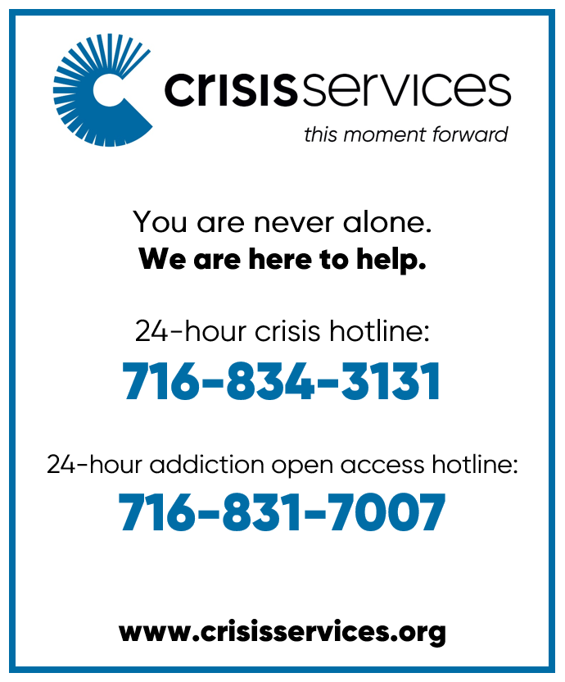

**Need a ride?**

If you are in need of a ride there

are resources available:

* Rural Transit Service-call 716.662.8378 for information
* Eden town car- call Eden Service Line at 716.992.3067
* Hamburg Van Service- call 716.646.0665

We can help YOU with your prayers. God is waiting for

your requests. Call us with any you might have. Please

make your special prayer

requests by calling our

Prayer Chain Coordinator,

Morgan Parnitzke at

716.992.9112.



Please make your special prayer requests by calling

our Prayer Chain

Coordinator,

Tina Rigley

at 992.9112 or

texting 998.8726.

**PRAYERS**

**WE ARE HAPPY** to honor requests for prayersfor the sick especially when they are in the hospital, in rehab, in hospice or in a post op recovery. When your loved one has improved, please be sure to call Lisa Beller at 716.992.9112sowe can remove their names from the prayer list.

Periodically, the prayer committee will remove names from the prayer list. If you would like someone put back on, please contact Pastor Lutz or Lisa Beller at 716.992.9112.

**IN SYMPATHY**

We would like to express our heartfelt sympathy to Cally Burkhart and her family. Her father, Albert Burkhart, passed on to his eternal home.May God's love and peace bring Cally and her family comfort during this difficult time.

Our most sincere condolences to Laurie Agle and her family. Her dear daughter-in-law, Stefanie Wutz, entered heaven on Christmas. We pray for God's love and grace to be with you and your family during this time of grief.

Please keep Nancy Theriault and her family in your prayers. Her brother, Roger Rogers was called to his heavenly home. We pray for Our Lord’s continual love and peace to bring their family comfort.

**IN OUR PRAYERS** for the Lord's healing power we include the following members:

* **Rose Hofner**
* **Harvey Quigel**
* **Laura Feasley**
* **Cally Burkhart**
* **Gail Agle**
* **Cindy Brearley**
* **Laurie Morris**
* **Tom Gabel**

**PRAYER LIST**

Please contact the church office at 716.992.9112 to have a loved one placed on the Prayer List.

**IN OUR PRAYERS** for the Lord's healing power we include the following family and friends of our church members:

* **Sue Kester** (Lynn Gerber’s friend)
* **Daniel Snyder & Holly Uebhuler** (Jeff Snyder’s father & sister)
* **Julie Buzzard** (Kirsten Henderson’s friend)
* **Bill Robison III**
* **Annette Bove & Jennifer Brooks** (Amy Smith’s friends)
* **Joanne Pepper** (Patty Smoot’s friend)
* **Janice McKay** (Eileen Seltzer’s mother)
* **Laurie** (Gary Holscher’s friend)
* **Mary Hewson** (Nancy Theriault’s friend)
* **Ken Roberts** (Charmayne Zieziula’s family)
* **Laurie Gabel** (Dan Goodemote’s mother)
* **Angela, Darlene & Khadijah** (Mary Logan’s friends)
* **Maureen** (Dennis Horrigan’s sister)
* **Tamara Hoelscher** (Betty Gabel’s friend)

*Don't be afraid, for I am with you. Don't be discouraged, for I am your God. I will strengthen you and help you. I will hold you up with my victorious right hand.* –Isaiah 41:10

**ALTAR FLOWERS**

If there is a special date or a person you would like to honor, please consider placing flowers on the Altar. Please call Lisa Beller at 716.992.9112.

**JANUARY 5- In loving memory of Henry & Ruth Agle** by the Family

**JANUARY 12- OPEN**

**JANUARY 19-** **In loving memory of Our Parents and Grandparents** by Bill & Terry Zittel

**JANUARY 26- OPEN**

**FEBRUARY 2- In memory of my father, Robert Grazier, for his Heavenly Birthday** by Robin Palumbo

**BOOK CLUB**

Look for information about the next book club in the weekly church bulletin. Call Cheryl Colvin at 716.992.4032 if you are interested in joining or have any questions. New members are always welcome.

**D&D MEETING**

The next D&D meeting will be on Sunday, January 12 at 1 pm. Meet at Eden United Methodist Church. Please contact Pastor at 716.818.9860 for info.

*“You have crowned the year with Your bounty, And Your paths drip with fatness.”* –Psalm 65:11

HAPPY NEW YEAR!!

**AVERAGE WEEKLY**

**SUNDAY SCHOOL**

**ATTENDANCE**

**This includes youth and adult classes**

November 17- 36

Voters’ Mtg- no Adult Bible Study

November 24- 60

December 1- 5

Youth SS canceled due to weather

December 8- 61

December 15- 55

December 22- 56

**FINANCIAL**

**BAROMETER 2024**

Thru December 25, 2024

Budgeted to date $279,475

Given to date $299,900

**THANK YOU**

for your generous giving!!

All of our bills are

up to date!

**

***MANY THANKS FOR***

***CONTINUED SUPPORT***

***AND GENEROSITY!***

**AVERAGE WEEKLY**

**“IN-HOUSE” WORSHIP**

**ATTENDANCE:**

November 17- 127

November 24-156

Including Thanksgiving on 11/28

December 1- 35 (storm)

December 8- 113

December 15- 127

December 22- 161

**L.E.G.O.S. HOUSE**

The L.E.G.O.S. House is used for support groups, supervisions and continuing education for Stephen Ministers, as well as contracted counseling and Outreach/ Workshops. From January 1, 2024- November 30, 2024 total usage was: 399 times

**Information Update:**

Please contact Lisa Beller at

716.992.9112 if any of your

personal information has

changed. Remember to contact

us with your new address if you

are moving. Thank you!

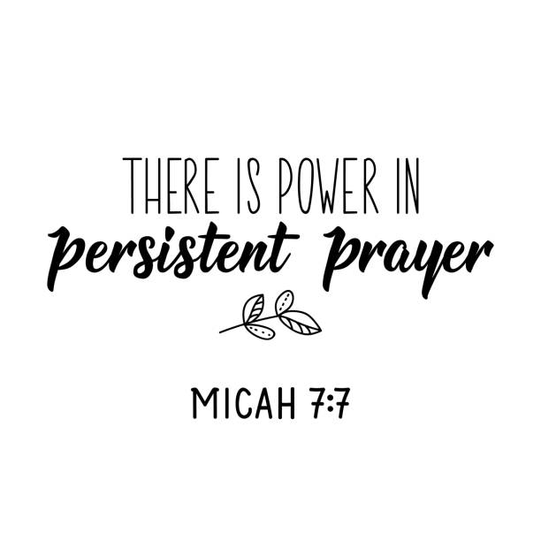

2025

Offering envelopes are

available and in the Narthex

**Youth News**

**Creation Kids (ages 2-5; PreK)**

**Wonder Kids (K-1st)**

**Discovery Kids (2nd-4th)**

**Confirmation Youth (5th-6th)**

**Inspire Youth Group (6th-12th)**



**CONFIRMATION CLASS**

Confirmation classes will resume (after a holiday break) on Tuesday, January 7 from 7-8 pm.

**YOUTH SPRING MUSICAL REHEARSALS**

Children in Pre-K to 4th grade are invited to be part of our Youth Spring Musical! Rehearsals will begin on Sunday, January 12, immediately following Sunday School and will end at 11 am. All children who are interested should meet in the Pre-K Sunday School room. If a child’s grown up is in late church they will be sent in to join them after rehearsal. Otherwise parents can pick up from church at 11 am.

Rehearsals will be the 2nd & 4th Sunday of the month and the performance will be on Sunday, April 6 during the 10:45 am service. Come be part of this special youth event which will tell the story of Jesus’ life through song!

**3rd ANNUAL CHILI COOK-OFF & DESSERT AUCTION**

Everyone is invited to our annual collaboration with our Lakeshore area churches. The event will be held at Trinity Lutheran Church in Silver Creek (15 Porter Ave, Silver Creek 14136) on Sunday, February 2 at 3 pm. People are invited to bring in their best chili. If you prefer not to make chili, please bring a side dish to complement the chili.

After some delicious chili we will have the dessert auction! Make your best dessert, a pie, a cake, cookies- whatever you do best! We will auction them off and the proceeds will support the ministry at St. John’s in Angola. Each year we pick a ministry from a different church to support. FYI- we will be auctioning off the whole dessert, not only a piece or two. Come join us for some fun and good eats before the Super Bowl and help continue to strengthen the bonds with the area Lutheran churches.

**LEGOS HOUSE FUNDRAISER**

Thank you to everyone who purchased an ornament (designed and sold by our Inspire Youth Group) to support the LEGOS House. The LEGOS House continues to provide a safe, confidential environment for Christian care.

**THE GIVING TREE**

A huge heartfelt thank you to all who purchased gifts for the Giving Tree this year! Every gesture was truly appreciated by families in need.

**CHRISTMAS CAROLING**

How easy it can be to spread joy! Thank you to the adults and youth who brought so much happiness to others by giving some time to spread Christmas cheer.

**COOKIE PACKS**

Thanks to our adult and youth volunteers who assisted in the packing of the much anticipated cookie packs! Our homebound members, nursing home residents and meals on wheels recipients loved them!

**CHRISTMAS TREE LIGHTING**

Thank you to everyone who joined us for this heartfelt, beautiful event! We would to thank Norm Bromley who coordinates this event each year, Brenda Bromley who helps him make tons of delicious cookies and Brett Sutherland and Morgan Parnizke who led the music. We were honored to have local Eden firefighters, who first arrived on the scene of the fire at St. Paul’s, do the tree lighting. There are no words to express how thankful we are for them and their dedication!

**MORE THANK YOUS**

Thank you to the snow shoveling crews who have been working hard on Sunday mornings to clear the snow for everyone!

Many thanks to all of our amazing volunteers!! The time that was given during 2024 by people who were shoveling, mowing, fixing, teaching, counting, caring, baking, organizing, quilting, ushering, preparing communion and so much more- were generous gifts given by those who are part of this St. Paul’s family. Your time, energy and commitment are appreciated so much. THANK YOU!!

**BABY CARE KITS**

Beginning in January and continuing through March, our Ladies’ Guild will be collecting items for the Lutheran World Relief’s Baby Care Kits. We welcome any contributions our church members would like to give.

**The items are specific ones and should be new or like new please.**

Sizes 6 months to 24 months may be used. They can be placed in the collection box found in the upstairs coatroom off of the Church Narthex. There are the items needed:

-Two light weight cotton T shirts

-Two long or short-sleeved gowns or sleepers WITHOUT FEET -One jacket, sweater, or sweatshirt with a hood or include a baby

cap

-Two bath-size bars (4-5 oz) of gentle soap, such as Dove or

Ivory

-Four cloth diapers, flat fold preferred

-One hand towel, dark color recommended

-Two pair of socks

-Two diaper pins or large safety pins

Please DO NOT substitute other items for the ones listed. If you have any questions please call Jane Barlow at 716.646.3094.



Youth Musical:

The Story of Jesus

-1st rehearsal: January 12th

-Time: 10:30-11 am

-Where: Pre-k Sunday School

Classroom

*Open to Pre-k to 4th grade.*

*Children will be dismissed into*

*church after rehearsal or are to*

*be picked up at 10 am.*

Date of musical: Sunday, April 6

(during the 10:45 am service)