MARCH 2026

ST. PAUL'S LUTHERAN CHURCH
3487 NORTH BOSTON ROAD
EDEN, NY 14057
716.992.9112
Stpaulseden.com


Pastor: Rev. Thomas Lutz
Director of Ministries: Tina Rigley
Associate Director of Ministries: Morgan Gow
Administrative Assistant: Lisa Hoover-Beller
Organist: Jacob DeGarie
Caretakers: Kassidy Beller & Will Panitzke

LINKS to recordings of
our Worship Services
and all updates can be found on
our website: stpaulseden.com
Please call Pastor Lutz
(716.818.9860)
for any emergencies.


Join us on Facebook:

St. Paul’s Eden Worship (public group)

St. Paul’s Lutheran Friends (private group)

St. Paul’s Lutheran Church

Our Website
Don’t forget to check out our
amazing website! Information about services, events, programs and schedules can be
found there!
Go to:
stpaulseden.com

DOES THAT EVEN EXIST?
By Pastor Lutz
On February 8th I had to take my second MRI. Those who have had the test know that it is a very loud machine so they offer those being tested headphones so they can listen to music. So as I was lying on the flat surface that would retract into the machine one of the technicians asked, “What music would you like to listen to?” I, of course, said, “Heavy metal Christian. ”Shocked the technician said, “Does that even exist?” There was no time to explain so I said, “Just search for Thousand Foot Krutch.”
This is not a unique reaction, and even some who know it exists also wish it didn’t. As an example, I was looking for a new superhero novel series to listen to and I read a review of a book series I ended up trying that said, “God and superheroes don’t mix.” It’s interesting to me that people in the church and outside of it get upset when our faith is expressed outside of the expected channels.

I can understand those outside of the church questioning these things, but it bothers me when people in the church say God belongs in this artistic expression but not in the others. We preach as a church that God is not just for Sundays but should be a part of every aspect of our lives. Because of that there is Heavy Metal Christian Music and God and superheroes do mix. This is not about forcing faith into things but allowing these things to happen naturally. When faith is expressed in art naturally it is beautiful and awe inspiring. Just look at movie Ben Hur, which starred Charlton Heston, faith was not the central theme of the move, yet the scene where the blood flowed from the cross into the cave to heal the lepers is one of the most powerful I have ever seen. I pray that God is now raising up new artists unafraid to express their faith in whatever medium God has called them to.

Exodus 31:1-5 - "The LORD said to Moses, 'See, I have called by name Bezalel the son of Uri, son of Hur, of the tribe of Judah, and I have filled him with the Spirit of God, with ability and intelligence, with knowledge and all craftsmanship, to devise artistic designs, to work in gold, silver, and bronze, in cutting stones for setting, and in carving wood, to work in every craft.'"

We must always remember that God speaks to us through those he inspires through His Holy Spirit, may we not stand in the Spirits way.

IN-HOUSE WORSHIP SERVICES:
REGULAR SERVICES
Traditional Service
8:30 am (every week)
10:45 am (2nd & 4th Sundays)
Contemporary Service
10:45 am (1st, 3rd & 5th Sundays)
Wednesday Contemporary Service with Communion (Chapel)
11:15 am (2nd & 4th Wednesdays)

In addition to our in-house worship services, our live-stream worship services are on Facebook. Go to St. Paul’s Worship Group. Or go to our website: stpaulseden.com for a link.

LENTEN SERVICES
Lenten services will continue on the following Wednesdays: March 4, 11, 18 & 25 at 4:00 pm. **Please note: this time for services this year is different!!

OPTIONS FOR SEATING
There is a pew located towards the back of church to assist those with limited mobility. This includes people who utilize wheelchairs, walkers, canes or crutches due to physical challenges, recent surgeries or injuries. We hope this is a welcome addition for anyone who may need accommodations.

LADIES GUILD
Please consider checking out the Ladies’ Guild table in the Narthex. They are selling wonderful items that have been created by Ladies’ Guild members. All proceeds go directly back into the Guild to provide materials they use for service projects and missions.


GRIEFSHARE
GriefShare is a confidential, faith based support group. This program helps people as they deal with the emotions and life stressors that follow the death of a loved one. The groups are led by trained Stephen Leaders and Ministers and each session includes a video and group sharing. There will be a day session that begins on March 9 from 10:30 am-12 pm. This group will meet twice a month. The evening session will begin on March 18 from 6:30-8 pm and will be once a month.

If you have experienced the loss of a loved one and need support in your healing journey, I encourage you to consider trying this group. Griefshare can be helpful for those who have experienced loss years ago or more recently. Please feel free to reach out to Tina Rigley at 716-992-9112 or email tmrigley1012@yahoo.com if you have any questions or concerns or if you would like to sign up for a session. There are brochures available at church that have the schedules for both the day and night sessions.

ADULT BIBLE STUDY
Join Pastor on Sunday mornings at 9:30 for a Bible Study.

EDEN HEIGHTS BIBLE STUDY
Bible Study with Pastor Lutz and Pastor Kate (Eden United Methodist Church) will meet at 1:30 pm at Eden Heights. They will gather on Thursdays, March 12 & 26.

PEACEFUL CAREGIVER – DAY SESSION

We will meet on Wednesday, March 11 & 25 from 9:30 am-11 am.

DEVOTIONS AT FOUR CORNERS
Join Pastor at the Four Corners Café for a
Devotion/Bible Study on Thursday, March 5
at 8:30 am
Are you going
into the hospital for
any type of surgery?
Pastor Lutz
would like to “visit”
with you before your
surgery to pray
with you.
Please call the church
office (716.992.9112) or
Pastor’s cell
716.818.9860
to let him know
of your surgery.

ALZHEIMER’S
ASSOCIATION
Website: alz.org/wny
24/7 Helpline
1.800.272.3900



THE L.E.G.O.S.
House
A Community Spiritual
Support Center

For further information on
our support groups or to inquire about individualized Christian Care by a trained
Stephen Minister or staff
member, please call
716.992.9112.

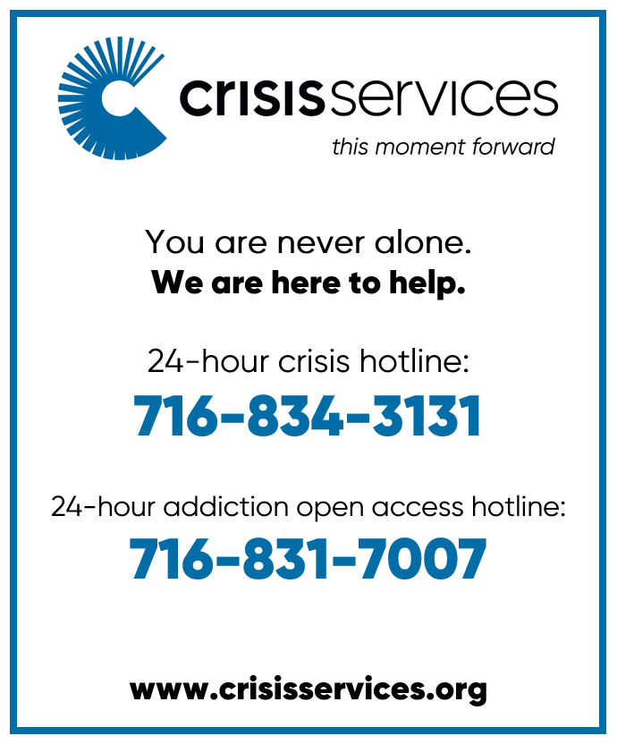

Need a ride?
If you are in need of a ride there
are resources available:
- Rural Transit Service-call 716.662.8378 for information
- Eden town car- call Eden Service Line at 716.992.3067
- Hamburg Van Service- call 716.646.0665

We can help YOU with your prayers. God is waiting for
your requests. Call us with any you might have. Please
make your special prayer
requests by calling our
Prayer Chain Coordinator, Morgan Parnitzke at
716.992.9112.


Please make your special prayer requests by calling
our Prayer Chain
Coordinator,
Tina Rigley
at 992.9112 or
texting 998.8726.

PRAYERS
WE ARE HAPPY to honor requests for prayers for the sick especially when they are in the hospital, in rehab, in hospice or in a post op recovery. When your loved one has improved, please be sure to call Lisa Beller at 716.992.9112 so we can remove their names from the prayer list.

Periodically, the prayer committee will remove names from the prayer list. If you would like someone put back on, please contact Pastor Lutz or Lisa Beller at 716.992.9112.

IN OUR PRAYERS for the Lord's healing power we include the following members:
- Pastor Lutz
- Rose Hofner
- Glenn Evertt
- Gary Holscher
- Kyle Gabel

- Inge Balko

PRAYER LIST
Please contact the church office at 716.992.9112 to have a loved one placed on the Prayer List.

IN OUR PRAYERS for the Lord's healing power we include the following family and friends of our church members:

- Harold Lutz
- Daniel Snyder & Holly Uebhuler (Jeff Snyder’s father & sister)

- Tricia, Nick & Caroline Mangino
- Bill Robison III
- Laurie (Gary Holscher’s friend)
- Angela (Mary Logan’s friend)
- Maureen (Dennis Horrigan’s sister)
- Mike & Michael (Terri Bradt’s friend and nephew)
- Michelle Senecal Hunt (Jennifer Klein’s friend)
- Ava (Brandi Sutherland’s niece)
- Cierra & Bert Theriault (Kit & Nancy Theriault’s granddaughter)
- Barbara Kelly (Terry Turnbull’s friend)
- Nancy (Wayne Schacher’s family)
- Teri Cross (Sandi Ploetz’s niece)
- Gretchen Rumfola & Annett Bove (former student & friend of Amy Smith)
- Joe L. (Danny & Robin Palumbo’s friend
- Ed Kleinke (Cally Burkhart’s friend)
- Sue Kester (Lynn Gerber’s friend)

OUR SYMPATHY & PRAYERS are with the family of Anthony (Tony) Gluszak who was called to his heavenly home on January 23, 2026.

OUR SYMPATHY & PRAYERS are with Joe Winiecki and family whose mother, Rita, was called to her eternal home.

RECEIVING THE BLESSING of Holy Baptism during the service on February 22 was Brielle Gian, daughter of Katelyn & Michael Gian, who was born on December 20, 2025. Serving as Godparents were Timothy & Alicia Morris.
ALTAR FLOWERS

If there is a special date you would like to have, please consider placing flowers on the Altar. Please call Lisa Beller at 716.992.9112.

MARCH 1 – To the Glory of God by Bill & Terry Zittel

MARCH 8- In loving memory of Mackenzie Johnnie Gibbons. Forever in our hearts! Love, Mommy, Daddy, Adeline & Taryn

MARCH 15- In loving honor and remembrance of Our Fathers, James A. Dix and Richard L. Kennedy Love from the Family

MARCH 22- In loving memory of Our Parents, Clinton & Sarah Hardy and Amos & Loretta Zittel by Paul & Linda Zittel
MARCH 29- In loving memory of Amos & Loretta Zittel and John & Phyllis Brzezicki by George & Julie Zittel and Family

COMFORT COMPANIONS
Thank you to all who donated to support the Comfort Companion ministry. Baby dolls and stuffed animals were distributed in the memory care unit at Gowanda Rehabilitation & Nursing Center. This ministry was spearheaded by Marie Parnitzke and sponsored by Thrivent (thank you Ruth Ranke) and St. Paul’s. It was a beautiful event that represented the true meaning of our care and outreach ministries!

BOOK CLUB

The next scheduled book club will be on Monday, March 23 at 12 noon. This meeting will be the 21st year of book club!! As done in the past, there will be a celebratory lunch at Cheryl Colvin’s home. The book for March is “Band of Sisters” by Lauren Willig. The April book will be “The Seven Husbands of Evelyn Hugo.” Please let Cheryl know if you will not be attending the March meeting (716-992-4032). Anyone is welcome to join! Please contact Cheryl if you are interested.

AVERAGE WEEKLY
SUNDAY SCHOOL
ATTENDANCE
This includes youth and adult classes

February 1- 32
February 8- 49
February 15- 33
February 22- 32
FINANCIAL
BAROMETER 2026

Thru February 22, 2026
Budgeted to date $51,700
Given to date $60.715

THANK YOU
for your generous giving!!
All of our bills are
up to date!

MANY THANKS FOR
CONTINUED SUPPORT
AND GENEROSITY!

AVERAGE WEEKLY

“IN-HOUSE” WORSHIP
ATTENDANCE:

February 1- 93
February 8- 92
February 15- 100
February 22*- 161
*Includes 2/18 Ash Wed Service

L.E.G.O.S. HOUSE
The L.E.G.O.S. House is used for support groups, supervisions and continuing education for Stephen Ministers, as well as contracted counseling and Outreach/ Workshops.
From January 1, 2026- February 22, 2026 total usage was: 41 times

Information Update:
Please contact Lisa Beller at
716.992.9112 if any of your
personal information has
changed. Remember to contact
us with your new address if you
are moving. Thank you!

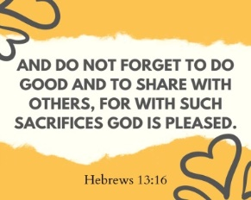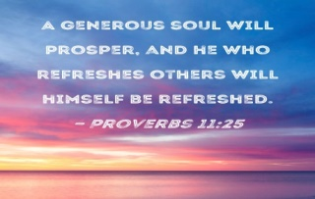

Youth News
Creation Kids (ages 2-5; PreK)
Wonder Kids (K-1st)
Discovery Kids (2nd-4th)
Confirmation Youth (5th-6th)
Inspire Youth Group (6th-12th)



CONFIRMATION CLASS
Confirmation classes continue on Tuesday evenings from 7-8 pm.

YOUTH SPRING MUSICAL REHEARSALS
Rehearsals for the Youth Spring Musical- The Rainbow Promise will be immediately following Sunday School and will end at 11 am. Children should meet in the Fellowship Hall. The performance will be on Sunday, April 26 during the 10:45 am service in the Fellowship Hall.

SPRING FORWARD EVENT
All students 5th-12th grade are welcome to join us for a fun time celebrating the Spring and Easter season! Spring Forward will take place on Friday, March 20 (the first day of Spring) from 6:30-8 pm. We will have a challenging Easter egg hunt, creating a Light in the Darkness Jar and enjoying chocolate fondue! Feel free to bring a friend! PLEASE RSVP BY MARCH 15 with Mrs. Rigley or Miss Morgan so we can prepare enough supplies!!

FAMILY EGG HUNT

Join us on Sunday, March 29 at noon for our annual egg hunt! Children up to 4th grade and their families are invited to be part of this Easter tradition! The egg hunt will be in the cemetery if the weather allows- so please have proper footwear- it may be a bit wet and muddy! If the weather is inclement or the grounds are VERY wet, the egg hunt will take place indoors. We will meet in the Fellowship Hall- hope to see you there!

EASTER LILIES
On Easter Sunday, April 5, the chancel will be decorated with white Easter lilies. All who wish to place lilies in the church are welcome to do so. Please have the plants DELIVERED by WEDNESDAY, APRIL 1 so they can be arranged for Easter service. The wrapping of the lilies should be in gold paper only. For later identification, please have your name on the plant. Also, please contact the Church Office by WEDNESDAY, APRIL 1 at 716-992-9112 if you are placing a lily on the altar. We will need info for the bulletin as to whether the plants are given in the memory or honor of a loved one or to the Glory of God. The plants may be taken home after the 10:45 am service on Easter morning. Flowers not taken after the service will be available to pick up the week following Easter.

Flowers ordered through Agles’ Farm Market (716-992-4290) will be delivered directly to the church. THE MARKET WILL OPEN FOR THE SEASON ON MARCH 18.

BABY CARE KITS
Our Ladies’ Guild will continue to collect items for the Lutheran World Relief’s Baby Care Kits through the month of March. They welcome any contributions our church members would like to give.

The items are specific ones and should be new or like new please.
Sizes 6 months to 24 months may be used. They can be placed in the collection box found in the upstairs coatroom off of the Church Narthex. There are the items needed:
-Two light weight cotton T shirts
-Two long or short-sleeved gowns or sleepers WITHOUT FEET -One jacket, sweater, or sweatshirt with a hood or include a baby
cap
-Two bath-size bars (4-5 oz) of gentle soap, such as Dove or
Ivory
-Four cloth diapers, flat fold preferred
-One hand towel, dark color recommended
-Two pair of socks
-Two diaper pins or large safety pins

Please DO NOT substitute other items for the ones listed. If you have any questions please call Jane Barlow at 716.646.3094.

