april 2026

ST. PAUL'S LUTHERAN CHURCH
3487 NORTH BOSTON ROAD
EDEN, NY 14057
716.992.9112
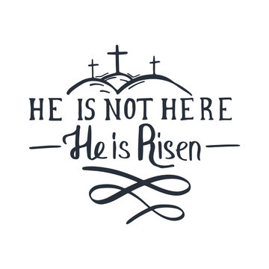
Stpaulseden.com

Pastor: Rev. Thomas Lutz
Director of Ministries: Tina Rigley
Associate Director of Ministries: Morgan Gow
Administrative Assistant: Lisa Hoover-Beller
Organist: Jacob DeGarie
Caretakers: Kassidy Beller & Will Parnitzke

LINKS to recordings of
our Worship Services
and all updates can be found on
our website: stpaulseden.com
Please call Pastor Lutz
(716.818.9860)
for any emergencies.


Join us on Facebook:

St. Paul’s Eden Worship (public group)

St. Paul’s Lutheran Friends (private group)

St. Paul’s Lutheran Church

Our Website
Don’t forget to check out our
amazing website! Information about services, events, programs and schedules can be
found there!
Go to:
stpaulseden.com

ALIVE IN CHRIST
By Pastor Lutz

⁴ But^{[c]} God, being rich in mercy, because of the great love with which he loved us, ⁵ even when we were dead in our trespasses, made us alive together with Christ—by grace you have been saved— ⁶ and raised us up with him and seated us with him in the heavenly places in Christ Jesus, ⁷ so that in the coming ages he might show the immeasurable riches of his grace in kindness toward us in Christ Jesus. –Ephesians 2

CHRIST HAS RISEN, ALLELUIA! HE HAS RISEN INDEED, ALLELUIA! Early in April we will celebrate Easter but it is our great pleasure as Christians to celebrate Jesus’ resurrection every day in our lives. For we who were dead in our sins have been alive in Christ Jesus! We do not have to wait for our death and resurrection to reap the benefits of what we celebrate at Easter.

We are alive right now and Christ’s words to Martha are manifested in us. “I am the resurrection and the life.^{[d]} Whoever believes in me, though he die, yet shall he live, ²⁶ and everyone who lives and believes in me shall never die.” God has made us eternal through our faith in Jesus’ death and resurrection, although this world and our bodies want us to think otherwise we will never die. Yes, these bodies will die but we will never die and our souls will live in our bodies then be glorified when Christ returns to the earth bringing heaven with Him.

As we touch death Christ reaches into our lives and snatches us from that death by connecting us to His death and resurrection through the Word and Sacraments. As the verse above tells us, He comes to us with His great love for us and raises us with Him in heavenly places. He forgives our sins and empowers us to be stronger when we face that temptation again. Praise be our God who loves us even when we were His enemies! So go every day and celebrate the death and resurrection of Jesus by confessing your sins and hearing God’s absolution through studying His Word, remembering your Baptism and partaking of the Lord’s Supper! CHRIST HAS RISEN, ALLELUIA! HE HAS RISEN INDEED, ALLELUIA!

IN-HOUSE WORSHIP SERVICES:
REGULAR SERVICES
Traditional Service
8:30 am (every week)
10:45 am (2nd & 4th Sundays)
Contemporary Service
10:45 am (1st, 3rd & 5th Sundays)
Wednesday Contemporary Service with Communion (Chapel)
11:15 am (2nd & 4th Wednesdays)

In addition to our in-house worship services, our live-stream worship services are on Facebook. Go to St. Paul’s Worship Group. Or go to our website: stpaulseden.com for a link.

HOLY WEEK

Holy week is the time between Palm Sunday and Easter when our Lord endured ridicule, shame and death on the cross. We look back to the events of that week with THREE days of special services.

PALM SUNDAY
March 29 8:30 am & 10:45 am

MAUNDY THURSDAY
April 2 7 pm

We remember the day when our Lord instituted His Holy Supper. Communion will be celebrated.


GOOD FRIDAY
April 3 NOON Service
Observance of Christ’s death
April 3 7pm
The Good Friday Tenebrae Service dramatically brings us the meaning of Christ’s death on the cross. The lights and candles in the Church are gradually extinguished until there is total darkness. The return of the Christ candle foreshadows the great event of Easter morning.

EASTER SERVICES
April 5 8:30 am & 10:45 am
Festival Services (with Communion)
**THERE IS NO SUNDAY SCHOOL OR ADULT BIBLE STUDY ON EASTER- PLEASE JOIN US FOR THE EASTER FELLOWSHIP EVENT in the Fellowship Hall between services.

OPTIONS FOR SEATING
There is a pew located towards the back of church to assist those with limited mobility. This includes people who utilize wheelchairs, walkers, canes or crutches due to physical challenges, recent surgeries or injuries. We hope this is a welcome addition for anyone who may need accommodations.

ADULT BIBLE STUDY
Join Pastor on Sunday mornings at 9:30 for a Bible Study.

BIBLE STUDIES
EDEN HEIGHTS BIBLE STUDY
Bible Study with Pastor Lutz & Pastor Kate (Eden United Methodist Church) will meet at 1:30 pm at Eden Heights on April 9th.

PEACEFUL CAREGIVER
The evening group will continue on Monday, April 27 from 7-8:30 pm at the LEGOS House.
PEACEFUL CAREGIVER
The day time group will meet on Wednesday, April 8 from 9:30-11 am at the LEGOS House.

DEVOTIONS AT FOUR CORNERS
Join Pastor at the Four Corners Café for a Devotion/Bible Study! The group will meet on Thursday, April 2 at 8:30 am.

QUILT & BABY CARE KITS DEDICATION
On Sunday, April 19 the beautiful quilts created by our Ladies’ Guild members and the Lutheran World Relief’s Baby Care Kits that the ladies’ assembled for distribution will be dedicated. Many thanks to those who donated and a special thank you to our dedicated Ladies’ Guild and the wonderful projects they do to help others!

THANK YOU
I want to thank our Ladies’ Guild members and members of the congregation for their generous contributions for our Lutheran World Relief’s Baby Care Kits.

Our goal was to complete 20 kits and we reached 23 instead. Thank you again. –Jane Barlow

LADIES GUILD
Please consider checking out the Ladies’ Guild table in the Narthex. There are many special, homemade items for sale. All proceeds go directly to the Ladies’ Guild missions. Your support is greatly appreciated!

BOOK CLUB
The next book club meeting will be on Monday, April 13 at the home of Jean Klug. Please let Cheryl Colvin know if you need the book. Anyone is welcome to join! Please contact Cheryl at 716-992-4032 if you are interested.

Are you going
into the hospital for
any type of surgery?
Pastor Lutz
would like to “visit”
with you before your
surgery to pray
with you.
Please call the church
office (716.992.9112) or
Pastor’s cell
716.818.9860
to let him know
of your surgery.

ALZHEIMER’S
ASSOCIATION
Website: alz.org/wny
24/7 Helpline
1.800.272.3900



THE L.E.G.O.S.
House
A Community Spiritual
Support Center

For further information on
our support groups or to inquire about individualized Christian Care by a trained
Stephen Minister or staff
member, please call
716.992.9112.

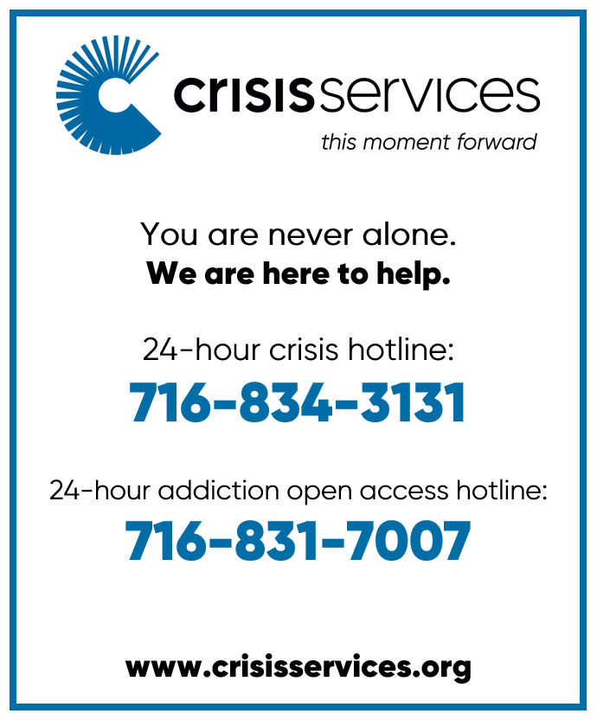

Need a ride?
If you are in need of a ride there
are resources available:
- Rural Transit Service-call 716.662.8378 for information
- Eden town car- call Eden Service Line at 716.992.3067
- Hamburg Van Service- call 716.646.0665

We can help YOU with your prayers. God is waiting for
your requests. Call us with any you might have. Please
make your special prayer
requests by calling our
Prayer Chain Coordinator, Morgan Parnitzke at
716.992.9112.
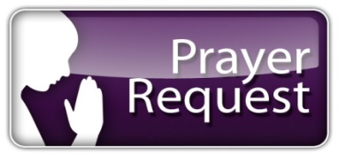

Please make your special prayer requests by calling
our Prayer Chain
Coordinator,
Tina Rigley
at 992.9112 or
texting 998.8726.

PRAYERS
WE ARE HAPPY to honor requests for prayers for the sick especially when they are in the hospital, in rehab, in hospice or in a post op recovery. When your loved one has improved, please be sure to call Lisa Beller at 716.992.9112 so we can remove their name from the prayer list.

Periodically, the prayer committee will remove names from the prayer list. If you would like someone put back on, please contact Pastor Lutz or Lisa Beller at 716.992.9112.

IN OUR PRAYERS for the Lord's healing power we include the following members:
- Pastor Lutz
- Rose Hofner
- Glenn Evertt
- Gary Holscher
- Kyle Gabel
- Pat Gabel
- Cheryl Snyder

OUR SYMPATHY & PRAYERS are with the family of Teresa Doering who was called to her eternal home on March 18.

OUR SYMPATHY & PRAYERS are with the family of Elsie Kelly who was called to her eternal home on March 18,
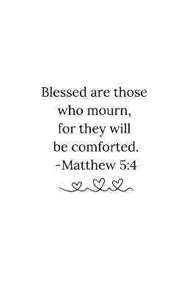

PRAYER LIST
Please contact the church office at 716.992.9112 to have a loved one placed on the Prayer List.

IN OUR PRAYERS for the Lord's healing power we include the following family and friends of our church members:

- Darlene (Danny & Robin Palumbo’s dear friend)
- Daniel Snyder & Holly Uebhuler (Jeff Snyder’s father & sister)
- JoAnne Pepper (friend of Patty Smoot)
- Bill Robison III
- Annette Bove & Gretchen Rumfola (Amy Smith’s friends)
- Joanne Pepper (Patty Smoot’s friend)
- Laurie (Gary Holscher’s friend)
- Angela (Mary Logan’s friend)
- Maureen (Dennis Horrigan’s sister)
- Mike (Terri Bradt’s friend)
- Tricia, Nick & Caroline Mangino
- Ava (Brandi Sutherland’s niece)
- Barbara Kelly (Terry Turnbulls’ friend)
- Teri Cross (Sandi Ploetz’s niece)
- Ed Kleinke (Cally Burkhart’s friend)
- Julie Buzzard (Kirsten Henderson’s friend)
- Cierra & Bert Theriault (Kit & Nancy Theriault’s family)
- Nancy (Wayne Schacher’s family)



ALTAR FLOWERS
If there is a special date you would like to have, please consider placing flowers on the Altar. Please call Lisa Beller at 716.992.9112.

APRIL 5- EASTER LILIES

APRIL 13- In loving memory of Philip II by Phil & Ellyn Charette and Family
APRIL 19- In loving memory of David Nenno and the Hausser & Reason Families by the Nenno Family
APRIL 26- In loving memory of Joe Klug by Jean Klug, Julie Farrell, Jim Klug and Families

MAY 3- In loving memory of Mom & Dad and Grandma by Michelle, Greg, Owen & Caitlin Gonter

EASTER FELLOWSHIP EVENT
Please stop by the Fellowship Hall and join us after Early service or before Late service on Easter Sunday for some tasty morning goodies and fellowship.

We will be providing a light breakfast fare such as fresh fruit and baked goods, along with coffee, tea and juice. The food and drinks will be available from 9:30-10:30 am.

QUILT RAFFLE
The lovely quilt being raffled was made by Gladys Eckhardt and is on display in the church. The drawing for the quilt will be on Mother’s Day, May 10. The money received will benefit our Ladies’ Guild. Tickets are $1. Please see the Church Office Staff to purchase a ticket. Thank you
AVERAGE WEEKLY
SUNDAY SCHOOL
ATTENDANCE
This includes youth and adult classes

March 2- 41
March 9- 45
March 16- 43
March 23- 40

FINANCIAL
BAROMETER 2026

Thru March 22, 2026
Budgeted to date $78.445
Given to date $85,060

THANK YOU
for your generous giving!!
All of our bills are
up to date!

MANY THANKS FOR
CONTINUED SUPPORT
AND GENEROSITY!

AVERAGE WEEKLY

“IN-HOUSE” WORSHIP
ATTENDANCE:

March 1-115
( Lent Service) March 4- 22
March 8- 90
(Lent Service) March- 18
March 15- 135
(Lent Service) March 18- 17
March 22- 104
(Lent Service) March 25- 12

L.E.G.O.S. HOUSE
The L.E.G.O.S. House is used for support groups, supervisions and continuing education for Stephen Ministers, as well as contracted counseling and Outreach/ Workshops.
From January 1, 2026- March 22 total usage was: 60 times

Information Update:
Please contact Lisa Beller at
716.992.9112 if any of your
personal information has
changed. Remember to contact
us with your new address if you


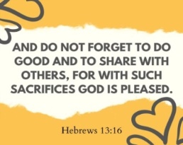

Youth News
Creation Kids (ages 2-5; PreK)
Wonder Kids (K-1st)
Discovery Kids (2nd-4th)
Confirmation Youth (5th-6th)
Inspire Youth Group (6th-12th)



CONFIRMATION CLASS
Our 1st year Confirmation students have concluded their classes for this year. They are expected to attend the Statement of Faith presentations on Tuesday, April 14 at 7pm.

The Statement of Faith Presentation will be on Tuesday, April 14 at 7pm with cake and punch served immediately following the presentations. There will be Confirmation practice on Tuesday, May 26 and Confirmation Sunday will be during the 10:45 am service on June 7.

YOUTH SPRING MUSICAL
Mark your calendars! The Rainbow Promise, a sweet story telling version of “Noah’s Ark” will be performed on Sunday, April 26 at the 10:45 am worship service. This service will be held in the Fellowship Hall with refreshments to follow!

STATEMENT OF FAITH PRESENTATIONS

On Tuesday, April 14 at 7pm, our 2nd year Confirmation students will be presenting their Statements of Faith. Please join us in supporting our Confirmation youth: Nat Crouthamel, Alexander Henry, Camden Parnitkzke, Blake Rowland, Nina Soto, Avery Stumpf and Nathan Zygmunt.

