September 2026

ST. PAUL'S LUTHERAN CHURCH
3487 NORTH BOSTON ROAD
EDEN, NY 14057
716.992.9112
stpaulseden.com
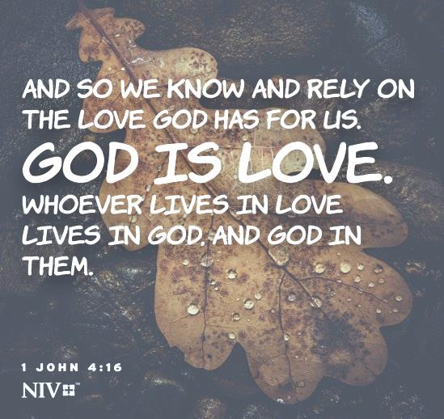

Pastor: Rev. Thomas Lutz
Director of Ministries: Tina Rigley
Associate Director of Ministries: Morgan Gow
Organist: Jacob DeGarie
Caretakers: Kassidy Beller and Will Parnitzke

LINKS to recordings of
our Worship Services
and all updates can be found on
our website: stpaulseden.com
Please call Pastor Lutz
(716.818.9860)
for any emergencies.


Join us on Facebook:

St. Paul’s Eden Worship (public group)

St. Paul’s Lutheran Friends (private group)

St. Paul’s Lutheran Church

Our Website
Don’t forget to check out our
amazing website! Information about services, events, programs and schedules can be
found there!
Go to:
stpaulseden.com

Changing of the Seasons
By Pastor Lutz
As fall approaches, we once again face the changing of the seasons. Some of us welcome the upcoming change that means cooler nights and trees with beautiful colors. Others lament the loss of longer days and a warmer climate. Either way, we accept that we cannot do anything about this change and we simply accept it. Seasons come and go. However, we often have a much different outlook upon the changes of seasons in our life- as we become older. Many of us are in denial about the changes that happen in our bodies and rail against how life has changed. We long for the days that once were yet, as the change from summer to fall happens, there is nothing we can do to stop it. We can lie to ourselves and deny the number of years we have lived, but the truth remains the truth.
Instead of mourning that our lives are no longer what they were, we can embrace the change we can affect. The greatest change in our lives is when we go from death to life, when we believe in Jesus Christ’s death and resurrection- we who were once dead in our transgressions have been alive in Jesus. This is all God’s work in us, of course, we do not save ourselves. However, this change does give us the opportunity to embrace that change and to continue to grow in our faith and the goodness in our lives! Philippians 1 says,
⁶being confident of this, that he who began a good work in you will carry it on to completion until the day of Christ Jesus.
Notice it says that God (He) began a good work in you and it won’t be complete until the second coming of Christ. This means that every day we are changed to embrace the change that God continues to offer us in our daily lives. To change from people driven by the pain of the past to people driven by the love we have experienced in Christ. This can be difficult and Paul mentions this in Romans 7.
¹⁸For I know that good itself does not dwell in me, that is, in my sinful nature. For I have the desire to do what is good, but I cannot carry it out. ¹⁹For I do not do the good I want to do, but the eveil I do not want to do-this I keep on doing.
Embracing change is hard, especially within ourselves. The world tells us that a person cannot change, but our faith tells us that change is the essence of faith, so who are we to believe? In Romans 12, we read:
Therefore, I urge you, brothers and sisters, in view of God’s mercy, to offer your bodies as a living sacrifice, holy and pleasing to God-this is your true and proper worship. ²Do not conform to the pattern of this world, but be transformed by the renewing of your mind. Then you will be able to test and approve what God’s will is-his good, pleasing and perfect will.
True change in Christ only comes when we let go of what “we” believe is right and embrace what God teaches us is right! We need to let go of our preconceived notions of things and let our faith truly change us. The love of God for all of humanity lead Jesus in His life, that same love needs to guide us in our own. Change and transformation in our lives happen when we pick up the cross and follow Christ, letting go of the teachings of the world and embrace the teachings of God. Like it tells us in Romans 7 it is hard, but the rest of scripture reminds us that it is not hopeless rather it is an ongoing process. Let us not worry about getting to a certain place but focus on the journey of faith, ever walking with Christ till we meet him face to face.

RALLY SUNDAY, SEPTEMBER 13
Sunday school starts on Sunday, September 13 and will run between 9:30-10:30 am. Please do not drop off your children before 9:30. Students who are in 2nd-12th grade can go directly to the Fellowship Hall for Sunday School opening, unless signs direct them otherwise. On Rally Sunday, the Inspire Youth group will be leading a special Sunday School project!

KICK OFF TO FALL EVENT, SEPTEMBER 20
On Sunday, September 20 we will be having an ice cream social and live music to celebrate the kick off to fall. The event will be at noon (immediately following late service). If the weather cooperates this will be an outdoor event. In the case of inclement weather we will be in the Fellowship Hall. There is no Bills game so stay and enjoy some fellowship!

IN-HOUSE WORSHIP SERVICES:
(Last 9:00 am Summer Service is Sept 6)
REGULAR SERVICES begin on September 13
Traditional Service
8:30 am (every week)
10:45 am (2nd & 4th Sundays)
Contemporary Service
10:45 am (1st, 3rd & 5th Sundays)
Wednesday Contemporary Service with Communion (Chapel)
11:15 am (2nd & 4th Wednesdays) *In September we will only have Chapel on the 4th Wednesday, September 23.*

In addition to our in-house worship services, our live-stream worship services are on Facebook. Go to St. Paul’s Worship Group. Or go to our website: stpaulseden.com for a link.

OPTIONS FOR SEATING
There is a pew located towards the back of church to assist those with limited mobility. This includes people who utilize wheelchairs, walkers, canes or crutches due to physical challenges, recent surgeries or injuries. We hope this is a welcome addition for anyone who may need accommodations!

HOPE AND HARMONY
Please join us for a special worship that provides an opportunity for devotion and spiritual reflection. The service is led by Morgan Gow and Kori Lutz-Doherty. Contemporary music will be the focal point of this worship, along with testimonies that will share faith based messages and fill your spirit. We will meet on a NEW NIGHT- MONDAY, OCTOBER 19 at 7 pm.

ADULT BIBLE STUDY
Join Pastor on Sunday mornings at 9:30 for a Bible Study.

DEVOTIONS AT FOUR CORNERS
Join Pastor at the Four Corners Café for a Devotion/Bible Study! The group will meet on Thursday, September 4 & 18 at 8:30 am.

EDEN HEIGHTS BIBLE STUDY
Bible Study with Pastor Lutz and Pastor Kate (Eden United Methodist Church) will meet at 1:30 pm at Eden Heights. They will gather on Thursday, September 11 & 25.

THE SMILE PROJECT
Be sure to check out the narthex, where we have set up some items that support the Smile Project. The items there have a suggested “donation” and can be purchased. All proceeds go directly back into the Smile Project. Please feel free to take an item and leave a donation. Our wish is to share faith, hope, love & comfort to those who need it. Do not hesitate to let us know if there is someone you feel may need the touch of the Smile Project in their life.

WOMEN’S BIBLE STUDY -RECLAIMING YOUR JOY
The heart of this study focuses on the amazing joy that Jesus readily offers us- not a partial joy dependent on circumstances and people. The hope is to learn to experience a full joy based in Him and His promises. The Bible study will meet on the fourth Monday of the month at the LEGOS House and the cost is $5. The first meeting will be on Monday, September 28 from 7-8:30 pm. Please contact Tina Rigley by September 13 so books can be ordered.

POLICY BORROWING CHURCH PROPERTY:
Tables and chairs can be requested to be borrowed by church members. Requests must be made with staff and accommodations made if scheduling allows. Items must be picked up and dropped off at a prearranged time when the staff is present. Drop off must be the following day after usage. Thank you!

Are you going
into the hospital for
any type of surgery?
Pastor Lutz
would like to “visit”
with you before your
surgery to pray
with you.
Please call the church
office (716.992.9112) or
Pastor’s cell
716.818.9860
to let him know
of your surgery.

ALZHEIMER’S
ASSOCIATION
Website: alz.org/wny
24/7 Helpline
1.800.272.3900

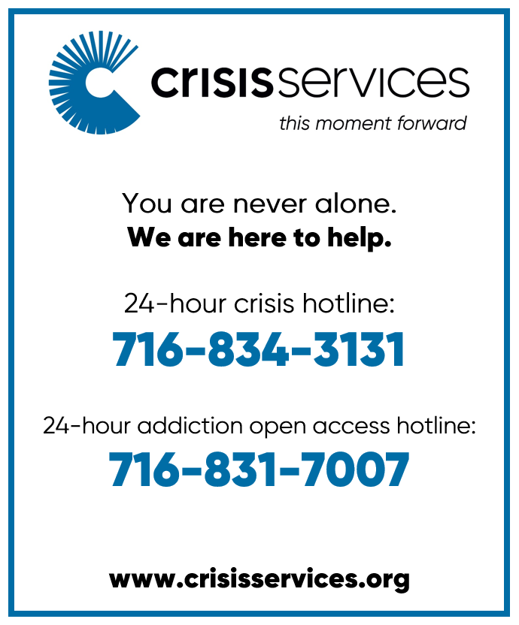

THE L.E.G.O.S.
House
A Community Spiritual
Support Center

For further information on
our support groups or to inquire about individualized Christian Care by a trained
Stephen Minister or staff
member, please call
716.992.9112.



Need a ride?
If you are in need of a ride there
are resources available:
- Rural Transit Service-call 716.662.8378 for information
- Eden town car- call Eden Service Line at 716.992.3067
- Hamburg Van Service- call 716.646.0665

We can help YOU with your prayers. God is waiting for
your requests. Call us with any you might have. Please
make your special prayer requests by calling our
Prayer Chain Coordinator,
Morgan Gow at
716-992-9112.
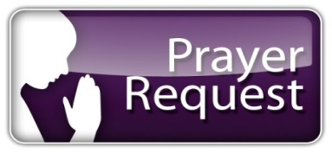

Please make your special prayer requests by calling
our Prayer Chain
Coordinator,
Tina Rigley
at 992.9112 or
texting 998.8726.

WE ARE HAPPY to honor requests for prayers for the sick especially when they are in the hospital, in rehab, in hospice or in a post op recovery. When your loved one has improved, please be sure to call the church staff at 716-992-9112 so we can remove their names from the prayer list.

Periodically, the prayer committee will remove names from the prayer list. If you would like someone put back on, please contact the church staff at 716-992-9112.

IN OUR PRAYERS for the Lord's healing power we include the following members:

- Rose Hofner
- Lynn Gerber
- Kyle Gabel
- Pat Gabel
- Cheryl Snyder

PRAYER LIST
Please contact the church office at 716-992-9112 to have a loved one placed on the Prayer List.

IN OUR PRAYERS for the Lord's healing power we include the following family and friends of our church members:

- Daniel Snyder & Holly Uebhuler (Jeff Snyder’s father & sister)
- Heidi & Family (Friend of Betty Gabel)
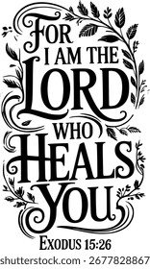
- Len Law
- Marlene Knott (Kirsten Henderson’s mother)
- David (Doris & Nelson’s son)
- Bill Robison III
- Laurie (Gary Holscher’s friend)
- Angela (Mary Logan’s friend)
- Maureen (Dennis Horrigan’s sister)
- Mike (Terri Bradt’s friend)
- Gretchen Rumfola & Annette Bove (Amy Smith’s friend)
- Darlene (Danny & Robin Palumbo’s friend)
- Barbara Kelly (Terry Turnbull’s friend)
- Lois (Ruth Ranke’s friend)
- Jared (friend of Pastor’s)
- Martha Reilly (niece of Cally Burkhart’s niece)
- Terri Cross (Sandi Ploetz’s niece)
- Baby Lola
- Jason Hunt (neighbor of Kit & Nancy Theriault)

IN SYMPATHY
Our prayers are with Heather Rowland and her family. Her father, Robert Rowland, was called to his eternal home on May 27.

Our prayers are with Kit Theriault and family. His brother, Bert Theriault, was called to his eternal home on August 1.

Please keep Carrie Bowen and family in your prayers. Her son, Chris Brooks, was called to his eternal home on August 3.
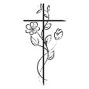
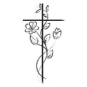

INFORMATION UPDATE:
Please contact Tina Rigley or Morgan Gow at 716-992-9112 if any of your personal information has changed. Remember to contact us with your new address if you are moving. Thank you.
ALTAR FLOWERS
If there is a special date or a person you would like to honor, please consider placing flowers on the Altar. Call the church office at 716-992-9112.

SEPTEMBER 6- Open

SEPTEMBER 13- For the Hausser Family in the US & Germany from the Nenno, Davis & Reason Families

SEPTEMBER 20- In loving memory of Clarence & Martha Cohoon by the Family




SEPTEMBER 27- In memory of Anthony and Bryce with love from Kelly Evertt and Family




THRIVENT MEMBERS
Giving back makes an important impact in people's lives. Last year alone, Thrivent Financial provided more than $100 million to help congregations, communities and individuals in need. Members who own Thrivent Financial products help make this support possible. Thrivent Choice lets you recommend where some of Thrivent Financials charitable outreach funds go by directing Choice Dollars. Remember: Even though you may have designated choice dollars in prior years, please check your account and make sure they are still designated to the non-profit of your choice. For information, please contact Jan Henry at 716.445.9974 or Jane Bohn at 716.992.3273. Thank you!

THANK YOU

A big thank you to our grounds crew and “flower ladies” who have been working hard all summer to keep our church, cemetery and LEGOS House grounds looking so beautiful!!

FINANCIAL
BAROMETER 2026

Thru August 9, 2026
Budgeted to date $211,050
Received to date $172,180

THANK YOU
for your generous giving!!
All of our bills are
up to date!

AVERAGE WEEKLY
SUNDAY SCHOOL
ATTENDANCE

Adult Bible Study
8-12 participants/week
(June- August)

No Sunday School
June-August

MANY THANKS FOR
CONTINUED SUPPORT
AND GENEROSITY!

AVERAGE WEEKLY

“IN-HOUSE” WORSHIP
ATTENDANCE:
June 7- 167 (2 services)

Summer Service (1 service)
June 14- 67
June 21- 73
June 28- 70
July 5- 78
July 12- 60
July 19- 80
July 26- 73
August 2- 63
August 9- 59
August 16- 68

L.E.G.O.S. HOUSE
The L.E.G.O.S. House is used for support groups, supervisions and continuing education for Stephen Ministers, as well as contracted counseling and Outreach/ Workshops. From January 1, 2026- August 19, 2026 total usage was: 307 times

Youth News
Creation Kids (ages 2-5; PreK)
Wonder Kids (K-1st)
Discovery Kids (2nd-4th)
Confirmation Youth (5th-6th)
Inspire Youth Group (6th-12th)



WELCOME BACK TO SUNDAY SCHOOL
Sunday, September 13 is Rally Sunday- our official start of Sunday school for the school year. We are so happy to have your children back with us on Sundays!

VACATION BIBLE SCHOOL
Vacation Bible School was a tremendous success! We had such a wonderful time and enjoyed all of the children who blessed us with their presence. The volunteers were so amazing! The majority of our helpers were youth and they were faithful, fun and patient. Their actions and words were such a reflection of God’s love! VBS was supported by Thrivent Action Team (thank you to April Agle).

CONFIRMATION CLASS
First and second year Confirmation students will begin class on Tuesday, September 22. Classes will be from 7-8 pm. Information will be mailed out in August. If you do not receive a mailing and your child is in 5th or 6th grade please contact Tina Rigley or Morgan Gow at 716-992-9112.

2ND GRADE BIBLES
On Sunday, September 20th our 2nd grade students will be presented with their bibles (at both services). God bless Hunter Chatwood, Ethan Noble, Margo Nowak and Ruby Ulrich on their faith journey!

“THE CHOSEN” EARLY PREMIERE

The Chosen is a historical drama TV series about the life of Jesus Christ. It is set in first-century Galilee and Judea and it follows Jesus and the everyday people who met, interacted and walked with him. Season 6, due to come out in November, will highlight the last 24 hours of Jesus’ life.

On Friday, September 18 at 6 pm we will host an early premiere of episode 1, season 6 of this authentic and intimate show. A special thank you to Connor Gow for providing us with information to get St. Paul’s signed up for this amazing opportunity to experience this episode TWO MONTHS EARLY. We will gather in the Fellowship Hall and have popcorn & drinks to enjoy!

FAITHFUL CREATIONS
On Wednesday, September 23 from 1-2:30 pm we will have a fall-themed Faithful Creation event. Join us for a devotion, beautiful sunflower string art and delicious fall snacks! You will have the opportunity to create a sweet apple treat that you can enjoy that day and take home to share! Cost is $5/person and the deadline to RSVP is September 20. Please see Tina or Morgan to sign up!

6TH ANNUAL TAILGATE PARTY

The Bills Make Me Want to SHOUT!! This is a wonderful adult fellowship event for Bills Mafia members (or just church members that want to have some fun)! Join us on Sunday, October 4 at 12:00 pm (1:00 pm game) to enjoy the Bills vs. the Patriots on the big screen on the Charette’s patio (3034 Bley Rd). Cost is $10/per person. Please be sure to bring: chairs, an appetizer to share, your beverage of choice, $10 per person fee and your team spirit! The following will be provided: pizza, wings, paper products, trivia questions & prizes and (OF COURSE) tons of fun! This is a Thrivent Action Team Event (thank you to Ben Heinrich). Please RSVP by September 27th to Phil (716-930-1519) or Ellyn (716-425-9274) or call 716-992-4040. Don’t miss out! Let’s Go Buffalo!!

LADIES NIGHT FALL EXTRAVAGANZA
Please join us for a time of fun and fellowship with the ladies of St. Paul’s! The event will take place on Friday, October 16 from 7-8:30 pm in the Fellowship Hall. This event will include a wine sampling and charcuterie board. There will be a devotion, game and a charcuterie board project for you to personalize!

We are asking each participant to bring one bottle of wine to share for the sampling and a food item to go on the charcuterie board. Wine samples will be limited and sample cups will be provided. YOU MUST RSVP BY OCT 11 FOR THIS EVENT. Space is limited!

FALL DINNER
Mark your calendars! This year’s Fall Dinner will be on Thursday, October 22 from 4pm-6pm. It will be DRIVE THRU ONLY. Tickets will be PRESALE ONLY and available starting September 13-October 18.


We continue to try to make our meals affordable and family friendly! The meal will include pulled pork, cheesy potatoes, applesauce, green beans and a roll. Cost for an individual meal is only $16. Family To Go Meal Packs will be available again this year. You can purchase one of these packs and receive the same amount of food as 4 separate dinners for the price of $55!! The Family To Go meals will be packaged family style and is a great option for family meal time! See the Church staff to purchase tickets. Proceeds will go directly to the LEGOS House.

