OCTOBER/
november 2026

ST. PAUL'S LUTHERAN CHURCH
3487 NORTH BOSTON ROAD
EDEN, NY 14057
716.992.9112
stpaulseden.com
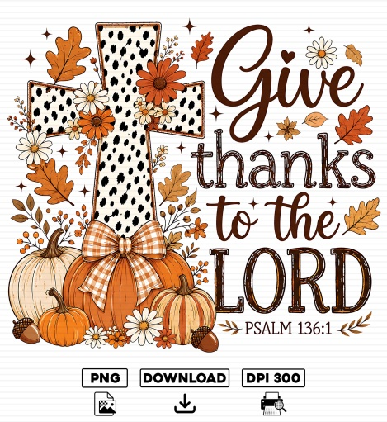

Pastor: Rev. Thomas Lutz
Director of Ministries: Tina Rigley
Associate Director of Ministries: Morgan Gow
Organist: Jacob DeGarie
Caretakers: Kassidy Beller and Will Parnitzke

LINKS to recordings of
our Worship Services
and all updates can be found on
our website: stpaulseden.com
Please call Pastor Lutz
(716.818.9860)
for any emergencies.


Join us on Facebook:

St. Paul’s Eden Worship (public group)

St. Paul’s Lutheran Friends (private group)

St. Paul’s Lutheran Church

Our Website
Don’t forget to check out our
amazing website! Information about services, events, programs and schedules can be
found there!
Go to:
stpaulseden.com

TIME OF THE HARVEST
By Pastor Lutz
We are in the time of reaping, also known as the harvest. This is when we bring in the fruits of what we have sown in the earth. This had me thinking about the harvest God is constantly reaping from the love He has sown into our hearts through the work of the Holy Spirit. I then began to reflect upon myself, “What have I been sowing in the hearts of others?” This is an important question underscored by these verses in Galatians 6.

⁷ Do not be deceived: God cannot be mocked. A man reaps what he sows. ⁸ Whoever sows to please their flesh, from the flesh will reap destruction; whoever sows to please the Spirit, from the Spirit will reap eternal life. ⁹ Let us not become weary in doing good, for at the proper time we will reap a harvest if we do not give up.

As we celebrate the harvest of the earth let us all be inspired to sow what God has given us freely, for you see we reap what we sow. Before we speak a word let us check and see if we are sowing love or discord for we will reap what we sow.

Throughout the scripture God is calling us to live out our faith, so what is sown in the hearts of the world may produce the peace and love we pray for every Sunday. We cannot change the world, but we watch God change ourselves and the people around us. This is how good overcomes evil (Rom. 12:21) when God uses us to sow the good seed of His love in the hearts of everyone around us.

ALL SAINTS SERVICE
On Sunday, November 1 Pastor will be doing a special service for All Saints. He is inviting people to send him ONE family picture that includes a loved one who has passed on to heaven. If you wish to do this please send it to Pastor at clement9@aol.com NO LATER than October 19.
PURPLE SUNDAY
Purple Sunday is a community and faith based awareness event where houses of worship dedicate services to educating congregations about Alzheimer’s disease and other forms of dementia. This year we will be having Purple Sunday on November 15-please wear purple!!! Purple is the color of Alzheimer’s Awareness. Raising awareness helps to break the stigma surrounding memory loss, encourages early detection and provides information on warning signs and risk factors. A representative from Alzheimer’s Association will be joining us during the Adult Bible study hour (9:30-10:30) to provide information about the organization and answer questions.

THANKSGIVING WORSHIP SERVICE
Thursday, November 26 at 10 am.

CHAPEL -Contemporary Service with Communion
Chapel will be held at 11:15 am on Wednesday, October 14 & November 11.

IN-HOUSE WORSHIP SERVICES:
REGULAR SERVICES
Traditional Service
8:30 am (every week)
10:45 am (2nd & 4th Sundays)
Contemporary Service
10:45 am (1st, 3rd & 5th Sundays)

In addition to our in-house worship services, our live-stream worship services are on Facebook. Go to St. Paul’s Worship Group. Or go to our website: stpaulseden.com for a link.

OPTIONS FOR SEATING
There is a pew located towards the back of church to assist those with limited mobility. This includes people who utilize wheelchairs, walkers, canes or crutches due to physical challenges, recent surgeries or injuries. We hope this is a welcome addition for anyone who may need accommodations!

HOPE AND HARMONY
Please join us for a special worship that provides an opportunity for devotion and spiritual reflection. The service is led by Morgan Gow and Kori Lutz-Doherty. Contemporary music will be the focal point of this worship, along with testimonies that will share faith based messages and fill your spirit. Join us on a NEW NIGHT- MONDAY, OCT 19 at 7 pm.

ADULT BIBLE STUDY Join Pastor on Sunday mornings at 9:30.

DEVOTIONS AT FOUR CORNERS
Join Pastor at the Four Corners Café for a Devotion/Bible Study! The group will meet on Thursday, Oct 15 & 29, Nov 5 & 19 at 8:30 am.

EDEN HEIGHTS BIBLE STUDY
Bible Study with Pastor Lutz and Pastor Kate (Eden United Methodist Church) will meet at 1:30 pm at Eden Heights. They will gather on Thursday, October 8 & 22 and November 12.

WOMEN’S BIBLE STUDY -RECLAIMING YOUR JOY
We will meet at the LEGOS House on Monday, October 26 & November 23 from 7-8:30 pm.

ADULT BIBLE STUDY
Join Pastor for a bible study on the following Wednesdays: October 14 & November 11 from 9:30-11 am.

BOOK CLUB
The Book Club will meet on Monday, October 19 at 1 pm at the LEGOS House. Please watch the bulletin for the November info.

LADIES’ GUILD
The Ladies’ Guild will meet on Tuesday, October 20 & November 17 at 9 am to work on Christmas booklets. There will be a meeting following the booklets and a bagged lunch at noon.

Be sure to check out the Ladies’ Guild Gift Shop in the Narthax! The proceeds go directly back into their mission work.

Are you going
into the hospital for
any type of surgery?
Pastor Lutz
would like to “visit”
with you before your
surgery to pray
with you.
Please call the church
office (716.992.9112) or
Pastor’s cell
716.818.9860
to let him know
of your surgery.

ALZHEIMER’S
ASSOCIATION
Website: alz.org/wny
24/7 Helpline
1.800.272.3900

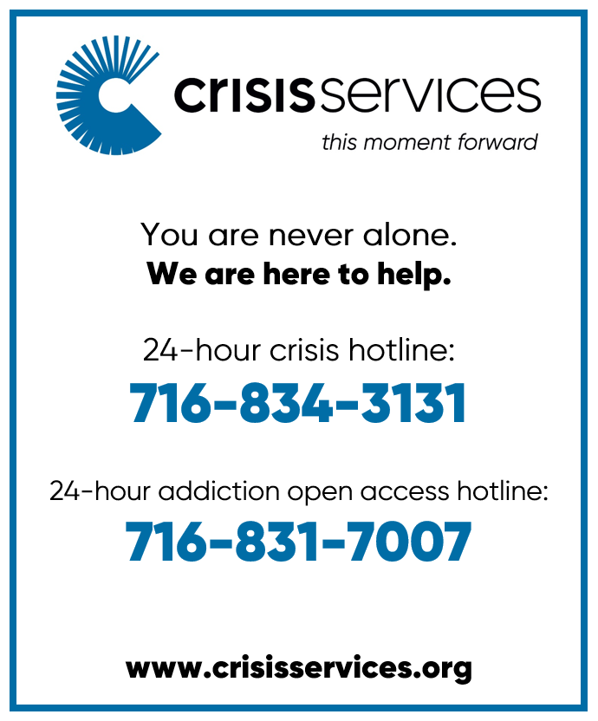

THE L.E.G.O.S. House
A Community Spiritual
Support Center

For further information on
our support groups or to inquire about individualized Christian Care by a trained
Stephen Minister or staff
member, please call
716.992.9112.



Need a ride?
If you are in need of a ride there
are resources available:
- Rural Transit Service-call 716.662.8378 for information
- Eden town car- call Eden Service Line at 716.992.3067
- Hamburg Van Service- call 716.646.0665

We can help YOU with your prayers. God is waiting for
your requests. Call us with any you might have. Please
make your special prayer requests by calling our
Prayer Chain Coordinator,
Morgan Gow at
716-992-9112.
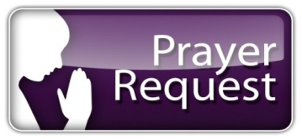

Please make your special prayer requests by calling
our Prayer Chain
Coordinator,
Tina Rigley
at 992.9112 or
texting 998.8726.

WE ARE HAPPY to honor requests for prayers for the sick especially when they are in the hospital, in rehab, in hospice or in a post op recovery. When your loved one has improved, please be sure to call the church staff at 716-992-9112 so we can remove their names from the prayer list.

Periodically, the prayer committee will remove names from the prayer list. If you would like someone put back on, please contact the church staff at 716-992-9112.

IN OUR PRAYERS for the Lord's healing power we include the following members:

- Rose Hofner
- Lynn Gerber
- Kyle Gabel
- Pat Gabel
- Cheryl Snyder
- Glenn Evertt

PRAYER LIST
Please contact the church office at 716-992-9112 to have a loved one placed on the Prayer List.

IN OUR PRAYERS for the Lord's healing power we include the following family and friends of our church members:

- Daniel Snyder & Holly Uebhuler (Jeff Snyder’s father & sister)

- Heidi & Family (Friend of Betty Gabel)
- Len Law
- David (Doris & Nelson’s son)
- Bill Robison III
- Laurie (Gary Holscher’s friend)
- Maureen (Dennis Horrigan’s sister)
- Mike (Terri Bradt’s friend)
- Gretchen Rumfola & Annette Bove (Amy Smith’s friend)
- Darlene (Danny & Robin Palumbo’s friend)
- Barbara Kelly (Terry Turnbull’s friend)
- Lois (Ruth Ranke’s friend)
- Jared (friend of Pastor’s)
- Jean O’Brien (Tracey Howard’s relative)
- Martha Reilly (Cally Burkhart’s niece)
- Terri Cross (Sandi Ploetz’s niece)
- Baby Lola
- Zach M.
- Dave Kaczmarski (friend of Cally Burkhart)
- Jason & Paul (friends of Kit & Nancy Theriault)
- Bob Linderfeld & Kather Ferrara (friends of Nelson & Doris Eckhardt)

IN SYMPATHY
We extend our most sincere sympathy to Kirsten Henderson and her family. Recently, her mother, Marlene went to her heavenly home. Please keep the Henderson family in your prayers.

Our sympathies go to out to Linda Jarnot and family. Her husband, Ray, went to his heavenly home on September 29. Please pray for Linda and her family.

INFORMATION UPDATE:
Please contact Tina Rigley or Morgan Gow at 716-992-9112 if any of your personal information has changed. Remember to contact us with your new address if you are moving. Thank you.

ALTAR FLOWERS
If there is a special date or a person you would like to honor, please consider placing flowers on the Altar. Call the church office at 716-992-9112.

OCTOBER 4- in loving memory of Mom & Dad by Donna, Kathy & Wayne Eckhardt

OCTOBER 11- in loving memory of Our Parents, Oscar & Louise Brusehaber by the Family

OCTOBER 18- in loving memory of Henry & Ida Bley, James & Sylvia Bley, Harold & Marilyn Bley and Emma Bauer by Jean Klug and family

OCTOBER 25- in loving memory of Gerald Agle and Thomas & Jane Johnson by Mark & Laurie Agle

NOVEMBER 1-in loving memory of Ray and Marion Klein from their loving daughters April, September & Vanessa

NOVEMBER 8- in honor of Our Parents, by Martin & Barb Henry & family

NOVEMBER 15- in loving memory of Harold & Alice Henry by Stephen & Suzanne Boies

NOVEMBER 22- in honor and remembrance of mom & dad love from the Dix family


NOVEMBER 29- in Joy & Thanksgiving by Carolyn Liljequist

AVERAGE WEEKLY
SUNDAY SCHOOL
ATTENDANCE

Adult Bible Study
Sept 6- 8
Sept 13- 17
Sept 20- 11

Sunday School
Sept 13- 27
Sept 20- 28

FINANCIAL
BAROMETER 2026

Thru September 27, 2026
Budgeted to date $257,600
Received to date
$199,425

THANK YOU
for your generous giving!!
All of our bills are
up to date!


MANY THANKS FOR
CONTINUED SUPPORT
AND GENEROSITY!

AVERAGE WEEKLY

“IN-HOUSE” WORSHIP
ATTENDANCE:

Summer Service (1 service)
August 23- 58
August 30-76
September 6- 64

Two Services
September 13- 121
September 20- 145

L.E.G.O.S. HOUSE
The L.E.G.O.S. House is used for support groups, supervisions and continuing education for Stephen Ministers, as well as contracted counseling and Outreach/ Workshops. From January 1, 2026- September 30, 2026 total usage was: 399 times





Youth News
Creation Kids (ages 2-5; PreK)
Wonder Kids (K-1st)
Discovery Kids (2nd-4th)
Confirmation Youth (5th-6th)
Inspire Youth Group (6th-12th)

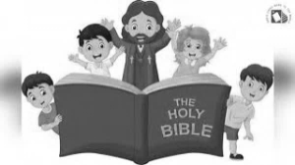

CROP WALK EVENT
The Crop Walk Event will take place for our K-12th grade students on Sunday, October 11. The event will include the students walking on church property and engaging in activities that will bring an increased awareness of food insecurity in our communities and beyond. A flyer with a permission slip & donation envelope will be sent home. Although donations are not required to be part of this event, they are greatly encourage and there will be prizes for the students who collect the most! Every student in grades K-12th grade who wants to participate MUST hand in a permission slip. Also, please dress appropriately (including footwear) to be outside. In the case of inclement weather, we will do the event in the Fellowship Hall.

Preschool students and any student who does not have a permission slip will stay inside to do a craft and video.

ALL SAINTS/ALL HALLOW’S EVE
Since this year All Saint’s falls on a Sunday we are combining All Saints and All Hallow’s Eve into one event for the youth. This event will take place during the Sunday School hour on Sunday, November 1st. There will not be a Sunday School opening- all students should go directly to their classroom.

INSPIRE YOUTH HALLOWEEN BASH
On Sunday, October 25 from 6-7:30 pm we will have having some Halloween fun for our oldest youth! We will have an apple dipping station, monster pizzas and a pumpkin painting challenge! Feel free to bring a friend! You must RSVP by October 18!!
MOVIE DAY/COOKIE MAKING
On Sunday, November 29 we will have a movie in the Fellowship Hall for grades preschool thru 5th grade. The Inspire Youth Group will be making cookies for the Christmas cookie packs. All students (including preschool, K & 1st grade) should go directly to the Fellowship Hall for Sunday School on that day.

YOUTH BELL CHOIR

Youth in grades kindergarten through 4th grade are invited to join the new Youth Bell Choir. The bells are color-coded and appropriate for young children. The practice days are times are as follows: (Sundays) Oct 11, 25; Nov 8,22; Dec13 from 10:30-11 am. The children will perform on Sunday, December 20 during the Youth Christmas Service (10:45 worship service). Please see Morgan if you are interested!

LADIES NIGHT FALL EXTRAVAGANZA
Please join us for a time of fun and fellowship with the ladies of St. Paul’s! The event will take place on Friday, October 16 from 7-8:30 pm in the Fellowship Hall. This event will include a wine sampling and charcuterie board. There will be a devotion, game, wine charms and a charcuterie board project for you to personalize!


We are asking each participant to bring one bottle of wine to share for the sampling and a food item to go on the charcuterie board. Wine samples will be limited and sample cups will be provided. YOU MUST RSVP BY OCT 11 FOR THIS EVENT. Space is limited!

FALL PULLED PORK DINNER
Mark your calendars! This year’s Fall Dinner will be on Thursday, October 22 from 4pm-6pm. It will be DRIVE THRU ONLY. Tickets will be PRESALE ONLY and available starting September 13-October 18.


We continue to try to make our meals affordable and family friendly! The meal will include pulled pork, cheesy potatoes, applesauce, green beans and a roll. Cost for an individual meal is only $16. Family To Go Meal Packs will be available again this year. You can purchase one of these packs and receive the same amount of food as 4 separate dinners for the price of $55!! The Family To Go meals will be packaged family style and is a great option for family meal time! See the Church staff to purchase tickets. Proceeds will go directly to the LEGOS House.

TALENT SHOW PREVIEW
On Sunday, October 25 we will have two opportunities for any youth or adults who would like to be part of our St. Paul’s Talent Show (which will be held on Friday, November 20 at 7pm). Morgan will be previewing all performances on 10/27 and discussing equipment or items needed for each act. If you would like to be part of this event please come to the Fellowship Hall between 9:30-10:30 (this is a great time for any youth to meet with her) or after late service from 11:45-12:15. We are looking for people who play instruments, sing, dance or have a special talent that they would like to share! Get creative and be part of the fun!

TALENT SHOW
Mark your calendars! Join us on Friday, November 20 at 7 pm to enjoy the many talents of St. Paul’s! Participants of all ages will be performing! We are asking everyone who attends to please bring a snack or appetizer to share! We will provide drinks and paper products. Don’t miss this fun night!

THANKSGIVING MEALS
TO BE DELIVERED TO THE
HOMEBOUND ON THANKSGIVING
We will be preparing and delivering Thanksgiving meals for the homebound and volunteers are NEEDED TO HELP DELIVER MEALS. Please call Tina or Morgan (716-992-9112) by November 15 if you wish to help!


Drivers are asked to arrive at church by 11 am (following worship service) and line up for pick up at the back door (the same procedure we use for pick up during church dinners). Each driver will be assigned a route and we will provide that information and your meals when you pull up.


Food or monetary donations for this outreach project are always appreciated. Monetary donations can be included in the offering (please put in an envelope labeled “Thanksgiving dinners”) and donation of food can be left in the kitchen by Nov. 16. Donations of food needed included cans of green beans and boxes of stuffing. Frozen turkeys are also appreciated but MUST be received by Nov. 15 so we can properly thaw them.

We appreciate all of the time and energy from everyone who helps us continue to make this event the blessing it is for so many! Thank you for all of your time and generosity!

OPERATION CHRISTMAS CHILD

Our 5th grade Sunday School class will begin collecting small items for their Operation Christmas Child Service Project. They will be accepting donations through Sunday, November 15. Some suggestions for the boxes include: school supplies (crayons, pens, pencils, markers), craft kits, socks, solar calculators, small toys or books, socks, hair clips, ball caps, sunglasses, flashlights, notebooks or coloring books. Please remember the items need to fit in a shoebox! DO NOT DONATE ITEMS SUCH AS: soap, candy, toothpaste, gum, used or damaged items, war related items or food. Items can be dropped off in the 5th grade Sunday School classroom or left in the labeled box in the library. Thank you in advance for supporting this amazing project!

Thrivent will be generously covering the postage so if any family would like to complete a box together at home, that is also an option. Please contact Jan Henry at 716-445-9974 with questions. Thank you for your gracious giving for this wonderful project!

VOTERS’ MEETING
The Voters’ Meeting will be held on Sunday, October 18 following late service (noon). We will be presenting the proposed 2027 budget.

ANNUAL CHRISTMAS TREE LIGHTING

Mark your calendars for this special annual event. Please join us at the Eden Town Square on Saturday, December 6. The ceremony will take place at 7:30 and the lighting of the tree will be at 8 pm.


There will be festive, holiday music, hot chocolate and cookies! Come and be part of this beautiful evening. Those attending are encouraged to bring an ornament to place on the tree. This event is sponsored by St. Paul’s and the Eden Chamber of Commerce.

OFFERING ENVELOPES
Reminder: if you need offering envelopes you can see Tina or sign the clipboard in the back of church. After you make your request your envelopes will be left on the back table for you the following Sunday. Thank you!

CHANGE IN NEWSLETTER SCHEDULE
In order to be more efficient with time and materials, the Church Board has approved a change in the newsletter schedules. We will be combining the newsletters as follows: Oct/Nov, Dec/Jan, Feb/Mar, April/May, June, July & August (summer) and September. Also, please be sure to read the weekly bulletin for important information. We also utilize Facebook and the St. Paul’s website to distribute important information regarding church and our many events and programs. Thank you!

THE SMILE PROJECT
In the Narthex there are items available that have a suggested “donation” and can be purchased. All proceeds go directly back into the Smile Project. Please feel free to take an item and leave a donation. Our wish is to share faith, hope, love & comfort to those who need it. Do not hesitate to let us know if there is someone you feel may need the touch of the Smile Project in their life.

POLICY BORROWING CHURCH PROPERTY:
Tables and chairs can be requested to be borrowed by church members. Requests must be made with staff and accommodations made if scheduling allows. Items must be picked up and dropped off at a prearranged time when the staff is present. Drop off must be the following day after usage. Thank you!

THRIVENT MEMBERS
Giving back makes an important impact in people's lives. Last year alone, Thrivent Financial provided more than $100 million to help congregations, communities and individuals in need. Members who own Thrivent Financial products help make this support possible. Thrivent Choice lets you recommend where some of Thrivent Financials charitable outreach funds go by directing Choice Dollars. Remember: Even though you may have designated choice dollars in prior years, please check your account and make sure they are still designated to the non-profit of your choice. For information, please contact Jan Henry at 716.445.9974 or Jane Bohn at 716.992.3273. Thank you!

